Welcome!
Helping Others Catch the Vision of Program Evaluation
AEA 2014

4:45 pm | Welcome & introductions
 | Evaluation Capacity pilot project
 | CDC Framework for Program Evaluation
5:00 pm | - Step 1: Engage stakeholders  Practice: role play scenarios
5:10 pm | - Step 2: Describe the program  Practice: create a logic model
5:30 pm | - Step 3: Focus the evaluation
- Step 4: Gather credible evidence
Practice: rewrite performance measures
5:55 pm | - Step 5: Justify conclusions
 | - Step 6: Ensure use
6:15 pm | Conclude – thank you!

Kristina Russell, MPH
Communicable Disease Investigation and Response Program
Utah Department of Health
801.538.9297
krisrussell@utah.gov

The CDC Framework for Program Evaluation
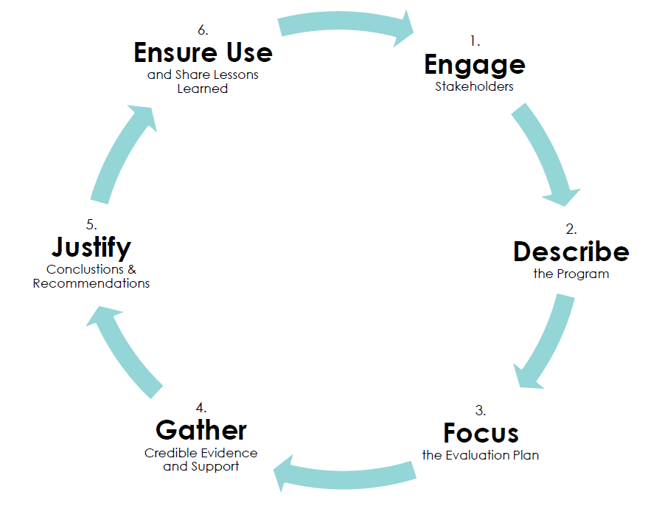
see cdc.gov/eval

How can a Logic Model help others “catch the vision”?
- A logic model is a picture (or road map) of how a program is intended to work
- This simple, useful tool:
  - Clarifies program theory - activities, outcomes, & their relationship
  - Shows the “big picture”
  - Identifies possible evaluation questions
Communicates quickly - what the program does & why it matters
Practice: Engage Stakeholders
Partner with the person sitting to your left, and role-play the scenarios below.

Scenario #1:
Partner 1: You have just been hired as an internal evaluator to assist the state’s foodborne illness surveillance and response team. Management wants this team to more clearly demonstrate the value of their work. This team has worked together for the past five years. You have a lot of experience with program evaluation, but no experience working with foodborne illness.
How could you help the team “catch the vision” of program evaluation?

Partner 2: You are a member of the foodborne illness team. You have been very busy lately investigating a large outbreak of foodborne illness, keeping track of all of the data and working with a variety of partners. You’re a bit worried that this evaluation effort will result in funding cuts, if you can’t come up with “good enough” results.
What would help you “catch the vision” of program evaluation?

Scenario #2:
Partner 1: You are an epidemiologist in the Communicable Disease program. You are very busy covering for an ill coworker, assisting with a pertussis outbreak in a local school, and developing emergency response plans in response to the Ebola threat. One day, you ask a co-worker about their new role as the “Evaluation Specialist”… secretly wondering if it’s a “real job”.
What would help you “catch the vision” of program evaluation?

Partner 2: You’ve worked in the Communicable Disease program of the state health department for a few years. You recently took on a new role as the Evaluation Specialist for the program. One day, a co-worker asks you (skeptically): “So what do you really DO, anyway?”
How could you help this person “catch the vision” of program evaluation?

What are the elements of a basic Logic Model?

- Inputs: what the program needs in order to function; might include staff, funding, partnerships, skills/experience, supplies, etc.
  - Example: Partnership with LHD epidemiologists and environmental health specialists
- Activities: what your program/staff will do.
  - Example: Provide LHD Trainings
- Outputs: tangible, countable, direct products of activities. Listing these in the model is optional, but these will be useful milestones to track.
  - Example: By 7/31/15, UDOH enteric team staff will conduct foodborne outbreak response trainings in six LHDs.
- Outcomes: who or what will change as a result of the program? May include changes in knowledge, attitudes, or beliefs; quicker public health response; policy changes; reduction of disease; etc.
- Short-term outcomes: what outcomes do you expect first? No specific time frame, but should be able to measure some progress within ~ one year.
  - Examples: Increased LHD knowledge of sampling techniques; increased number of food samples submitted from LHDs to UPHL.
- Mid-term outcomes: what outcomes do you expect next? You may not be able to measure these, especially within a short time frame, but still want to keep them in mind.
  - Example: Public health control measures implemented more quickly during foodborne disease outbreaks.
- Long-term outcomes: these are the “ultimate, end goal” outcomes – just because they’re in the model doesn’t mean you have to measure them (don’t worry!)
  - Example: Decreased incidence of enteric disease in Utah

Background: Program description for logic model exercise
Utah Department of Health Influenza Surveillance Program
The main purpose of the Utah Department of Health’s Influenza Surveillance Program (UDOH ISP) is to track influenza infections and guide intervention efforts. The UDOH ISP does this by participating in federal surveillance programs; collecting, analyzing, and disseminating hospitalization and laboratory testing data; ensuring that appropriate laboratory testing is available for influenza diagnosis; and communicating with other public health partners and healthcare providers. The UDOH ISP collaborates with the Centers for Disease Control and Prevention, Local Health Departments, clinics, hospitals and emergency departments, laboratories, and the UDOH Bureau of Vital Records.
These measures assist in local, national, and global efforts in influenza surveillance. With the data we collect we can rapidly determine when and where influenza activity is occurring. We assist in the effort to immediately detect unusual influenza viruses that could cause severe disease. Our surveillance efforts also assist in measuring the current impact that influenza has on hospitalizations and death. With our data we can assist health care providers in making treatment decisions that will best serve their patients. These efforts also assist in the selection of yearly vaccine components and guide immunization program planning efforts. Ultimately, the UDOH ISP collaborates with public health partners worldwide to prevent the spread of influenza, reduce the number of cases, and decrease deaths and serious complications due to influenza infection.

Practice: Create a logic model
Based on the program description provided, draw a logic model for the UDOH ISP.
Include these elements:

- Inputs
- Activities
- Short-term outcomes (for this exercise, less than 1 year away)
- Intermediate outcomes (for this exercise, ~1-5 years away)
- Long-term outcomes (“ultimate goals”)

Example: Completed Logic Model for UDOH ISP

Inputs | Activities | Short-Term Outcomes | Intermediate Outcomes | Long-Term Outcomes
Personnel:  - Utah Department of Health staff  - Hospital staff  - Laboratory staff  - CDC staff  Laboratory:  - Samples  - Supplies  - Equipment  Data and Systems:  - Data collection system  - Reports from hospitals and laboratories | Participate in federal surveillance programs  Collect, analyze, and disseminate data  Ensure that appropriate laboratory testing is available  Communicate with other public health partners and healthcare providers | Determine when and where influenza activity is occurring  Detect unusual influenza viruses  Measure impact of the disease  Provide data to guide healthcare decisions | Select yearly vaccine components  Guide immunization program planning | Prevent the spread of influenza  Reduce the number of influenza cases  Decrease deaths or serious complications due to influenza

Two types of performance measures
- Process measure: Were the program activities accomplished?
  - Example: UDOH staff will provide five Local Health Department Trainings, covering basic food sampling techniques, by 7/31/15.
- Outcome measure: Did anyone/anything change as a result of the program?
  - Example: Percentage of training attendees accurately describing three requirements for a viable food sample.

Baseline and target values for measures
- Baseline value = starting point
  - Already available, or needs to be established?
  - Can the actual value be derived from this same data source?
- Target value = what you aim to achieve during the reporting period
  - Realistic and achievable?
  - Substantial change from baseline?
  - (Optional) - benchmarked against similar work?

How will the data be collected and shared?
- How will this data be used?
- When will this data be most useful?
- Can you use existing data?
- Do you need to develop new data collection tools?

Background: Information for performance measure exercise
The Utah Department of Health is one of CDC’s Foodborne Diseases Centers for Outbreak Response Enhancement (FoodCORE) centers. FoodCORE centers work together to develop new and better methods to detect, investigate, respond to, and control multistate outbreaks of foodborne diseases.
FoodCORE's key areas are:
- Enhancement of public health laboratory surveillance
- Epidemiologic interviews and investigations
- Environmental health assessments

In the coming year, the UDOH FoodCORE team plans to provide training for Local Health Departments (LHDs). These training efforts will lead to a trained LHD workforce, better prepared to respond to foodborne disease outbreaks.
The training will consist of on-site, hands-on outbreak detection and reporting training for LHD epidemiology staff and environmental health specialists. LHDs will be taught:
- Why samples are important for detecting and solving outbreaks
- How to collect samples from food and environmental surfaces, and
- How to package and ship samples to the Utah Public Health Laboratory (UPHL).
This training will aim to engage and motivate LHD partners to improve timeliness and completeness of outbreak investigations, and increase the number of outbreak-related specimens submitted to UPHL. This, in turn, will increase UDOH’S ability to identify outbreaks of foodborne illness, pinpoint the source of these outbreaks, implement control measures, and prevent future outbreaks of foodborne illness.

Practice: Can this performance measure be improved?
Original Measure: Develop and implement foodborne illness outbreak training.
Is this a process or an outcome measure?
Why?
Criteria | Yes | No | Comments
Meaningful/relevant?
  - Connected to key questions and priorities?
  - Supported by stakeholders?
Precise/clear/specific?
  - Accurately measuring one thing?
  - Valid & logical?
Practical/feasible/cost-effective?
  - Does the benefit of the data outweigh burden, time, cost of collecting it?
Usable?
  - Will you and/or your stakeholders use this data? How?
Measurable/observable?
  - Is data available - can you measure it?
  - Is it non-biased?
Improved Measure:

Practice: Can this performance measure be improved?
Original Measure: Reduced number of foodborne illness outbreaks.
Is this a process or an outcome measure?
Why?
Criteria | Yes | No | Comments
Meaningful/relevant?
  - Connected to key questions and priorities?
  - Supported by stakeholders?
Precise/clear/specific?
  - Accurately measuring one thing?
  - Valid & logical?
Practical/feasible/cost-effective?
  - Does the benefit of the data outweigh burden, time, cost of collecting it?
Usable?
  - Will you and/or your stakeholders use this data? How?
Measurable/observable?
  - Is data available - can you measure it?
  - Is it non-biased?
Improved Measure:

For more on Program Evaluation:
American Evaluation Association (AEA): http://www.eval.org/
CDC Evaluation website: http://www.cdc.gov/eval/
Introduction to Program Evaluation for Public Health Programs – a Self Study Guide: http://www.cdc.gov/eval/guide/index.htm
Community Tool Box (University of Kansas): http://ctb.ku.edu/en/toolkits
Better Evaluation: http://betterevaluation.org/

For more on Logic Models:
“Tearless” Logic Model method: http://www.gjcpp.org/en/tool.php?issue=7&tool=9
Innovation Network: http://www.innonet.org/
Harvard Family Research Project: http://www.hfrp.org/evaluation
W.K. Kellogg Foundation: http://www.wkkf.org/resource-directory/resource/2010/w-k-kellogg-foundation-evaluation-handbook

For more on effective reporting & presentations:
Potent Presentations initiative: http://p2i.eval.org/
Garr Reynolds’ book: Presentation Zen (New Riders, 2011), and blog: http://www.presentationzen.com/
Stephanie Evergreen’s book: Presenting Data Effectively: Communicating Your Findings for Maximum Impact (Sage, 2013).
Excellent Excel tutorials: Ann K. Emery’s website: http://annkemery.com/
Free stock photos: https://medium.com/@dustin/stock-photos-that-dont-suck-62ae4bcbe01b
Graph Design “IQ test”: http://www.perceptualedge.com/files/GraphDesignIQ.html
Color themes: https://kuler.adobe.com/create/color-wheel/
Community Solutions/ Kylie Hutchinson: http://communitysolutions.ca/web/

