Integrating Systems Thinking through a Technology-based Performance Management System for a Consortium TAACCCT Grant

Christa A. Smith, TRAC-7 Research Analyst and Interim Program Manager
Debra E. Mikulka, TRAC-7 Administrator and Office of Sponsored Projects Director
Gillian M. Gabelmann, Project Director and Associate Dean of Technical Education
Technical Retraining to Achieve Credentials (TRAC-7)
Washburn University and Washburn Institute of Technology

Presented at the American Evaluation Association conference, October 16, 2014, Denver, Colorado.

Executive Summary
As a recipient of funding from the U.S. Department of Labor Employment and Training Administration (DOLETA) Trade Adjustment Assistance Community College and Career Training (TAACCCT) Grants Program, Washburn University, the lead institution of the Technical Retraining to Achieve Credentials (TRAC-7) Consortium, compiles data from the seven industry-specific programs and submits quarterly and annual reports as one entity. TAACCCT Grants include numerous and comprehensive measurement and monitoring systems. These include both numerical data and narrative summaries of grant performance by individual institution and for the entire consortium.

The purpose of this paper is to describe the systems processes that the TRAC-7 Consortium developed to create a common understanding of the data needed to accurately capture grantee performance and the innovative performance management system that was developed from these processes to better evaluate the interconnectedness of elements. A systems thinking perspective provided the foundation for the continuous improvement process to identify patterns and report consistent and valid performance data across a consortium of diverse institutions, and narratives that accurately communicated successes. This paper discusses how resources at the lead institution were leveraged to create the performance management system, and features the audience may find advantageous over commercially available or third-party developed software.

Introduction
TRAC-7 is a consortium of seven community colleges and technical schools in Kansas for which Washburn University serves as the lead institution. As a recipient of $19.6M in funding from the 2011 Round 1 DOLETA TAACCCT Grants Program, the lead institution is required to compile data from the consortium institutions and submit quarterly narrative progress reports (see 2011 DOLETA TAACCCT Notice of Availability of Funds and Solicitation for Grant Applications, Section VI. C. Reporting, page 34).

The TRAC-7 Reporting System is an online customized data management system developed in collaboration with Computer Information Science faculty at Washburn University. The purpose of the TRAC-7 Reporting System was to create a secure, online database for use as both a data entry tool for TRAC-7 Site Coordinators, and as a data analysis and storage tool for TRAC-7 Grant Management.

Method
A strategic planning session was held during the February 2013 TRAC-7 Site Coordinator meeting to re-examine the status of activities, progress measures, and implementation measures proposed in the TRAC-7 Statement of Work (SOW), and review reporting responsibilities for these metrics.
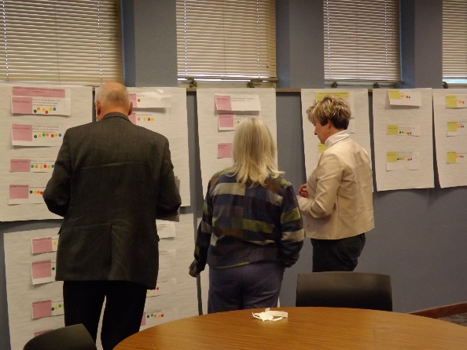
The facilitators conducted these sessions with a systems thinking approach (Reynolds and Williams, 2012) focused on building consensus and a common understanding of the interrelated components, mindful of the newly forming and existing relationships, and respectful of the boundaries and the potential for conflicts.
The activities, progress measures, and implementation measures from the SOW’s work plan were placed on large post-it sheets on the walls of a conference room. First, the definition of each metric was stated, and if needed, TRAC-7 Grant Management and Site Coordinators collaboratively operationalized definitions to assist with interpretation. Next, the TRAC-7 Site Coordinators were assigned colored dots that represented their consortium institution. The TRAC-7 Site Coordinators placed dots under the metrics for which they considered their responsibility for quarterly narrative progress reporting (see picture at right). The placement of the dots were discussed until consensus was reached.
The foundation for reporting was derived from these strategic planning sessions and spreadsheets were developed for data collection and entry using a cloud storage application. However, it was the frustrations expressed by users who were utilizing the static spreadsheets that led to the development of the TRAC-7 Reporting System. The inflexibility of user access, and duplicate and conflicted copies warranted the need for an online customized performance management system. The system was developed by leveraging existing resources within the university, namely the expertise of the Computer Information Sciences department. The performance management system was developed and placed online with secure user log-in access, and the ability to consolidate duplicated information.
A framework incorporating the activities, progress measures, implementation measures, definitions, indicators of progress, and those institutions responsible for reporting each metric were provided to the a programmer in the Washburn University Computer Information Science department. The framework was placed into an online database and secure user log-ins were added. The system allows the user to report both a quantitative self-assessment of progress toward outcomes and a qualitative explanation of progress. See Figure 1 for a screenshot of the reporting fields.

Figure 1. Screenshot of TRAC-7 Reporting System Fields
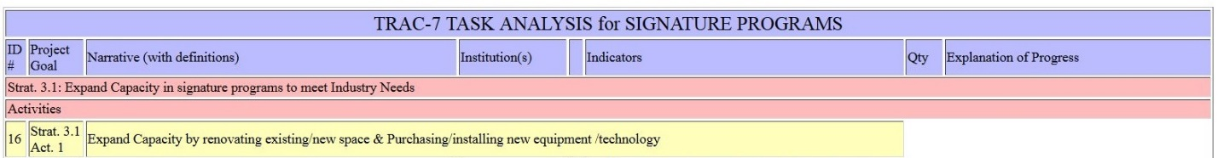
The TRAC-7 Reporting System had dual purposes: to create a secure, online performance management system to serve as a data entry tool for the seven institutions, and as a data analysis, management, and storage tool for TRAC-7 grant management. On the front end, the system allowed users to report both a quantitative self-assessment of progress toward outcomes and a qualitative explanation of progress that informed a process of continuous improvement. On the back end, TRAC-7 grant management used the performance management system for synthesizing and/or exporting quantitative data and summarizing qualitative comments for quarterly reporting.

Best Practices
The TRAC-7 Reporting System has a number of features that facilitate the quarterly reporting of multiple metrics across the seven institutions. Users are able to access the system by entering a web address into a web browser. Authorized users can login to the secure system using their institutional email address and an assigned password. See Figure 2 for an example of the TRAC-7 Reporting System Login Form.
Figure 2. Screenshot of TRAC-7 Reporting System Login Form
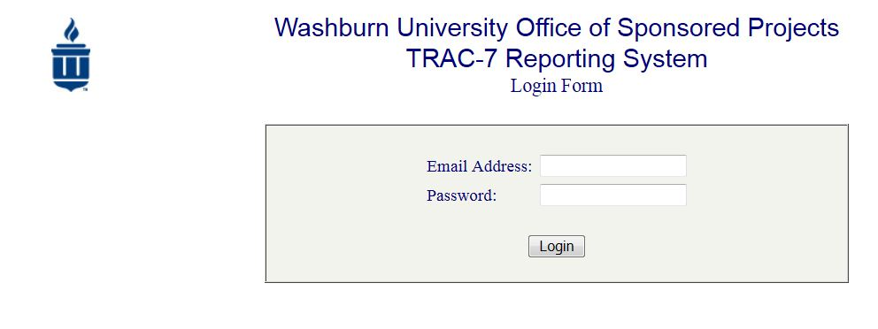
The TRAC-7 Reporting System can support multiple users for one consortium institution to allow for asynchronous, remote collaboration within institutions. Users have ability to view and enter data by quarter, and save partial submissions, which allows users to return later to update and/or submit final data. Once data is submitted for a quarter, that quarter is locked for editing by the users.
The previous quarter’s qualitative comments are populated into the new quarter to allow users to reflect on the previous entry and update comments if needed to provide richer, contextualized data.
The reported data, submission status, and authorized users can be managed by the system administrators. The system archives and sums the quantitative data per quarter. After entry and submission, data can be sorted by three Aggregate Report Types: institution, quarter, and institution and quarter. Figure 3 is an example of the TRAC-7 Reporting System Aggregate Report Type: Total by Quarter.
Figure 3. Screenshot of TRAC-7 Reporting System Aggregate Report Type: Total by Quarter.
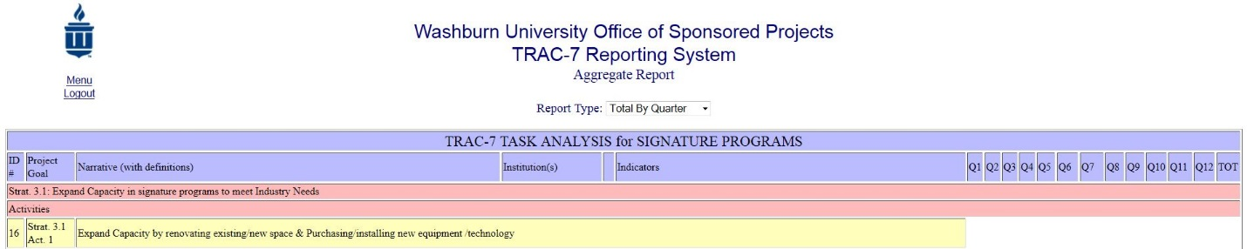
Each institution’s last saved data are timestamped, and the submission status for each quarter is noted in the submission log. Once submitted, data are reviewed and verified by system administrators and the data is “set.” Incorrectly reported data can be revised by changing the submitted status to “unset” which allows the user to enter the system, revise/update the data, and again save and/or submit. Authorized users can be added, removed, or granted limited access by the system administrators.

Limitations and Areas for Improvement
Building an online performance management system in-house has some advantages to purchasing commercially available or third-party developed software.
Reference
Reynolds, M. and Williams, B. (2012). Systems thinking and equity-focused evaluations. In: Segone, Marco ed. Evaluation for equitable development results. New York: UNICEF, pp. 115–141.

Disclaimer
This workforce product was funded by a grant awarded by the U.S. Department of Labor’s Employment and Training Administration. The product was created by the grantee and does not necessarily reflect the official position of the U.S. Department of Labor. The U.S. Department of Labor makes no guarantees, warranties, or assurances of any kind, express or implied, with respect to such information, including any information on linked sites and including, but not limited to, accuracy of the information or its completeness, timeliness, usefulness, adequacy, continued availability, or ownership.

This paper was developed for the Trade Adjustment Assistance Community College and Career Training (TAACCCT) Grant Program Round 1 Grant, Technical Retraining to Achieve Credentials (TRAC-7): TC-22513-11-60-A-20.

Integrating Systems Thinking through a Technology-based Performance Management System for a Consortium TAACCCT Grant by Technical Retraining to Achieve Credentials (TRAC-7) is licensed under a Creative Commons Attribution 3.0 Unported License.

