American Evaluation Association Conference - November 2015

Integrating Evaluation & Learning in Foundations
Amidst Organizational Changes

Shared Context
- Foundation focus: health; underserved populations; focus on California
- Organizational changes: new leadership; strategic planning; staff changes

The California Wellness Foundation
- Identify: Determine grantmaking strategies; set up systems to track effects of funding.
- Test: Award grants to organizations.
- Document: Document what resulted from the funding.
- Learn: Reflect and learn from the data.
- Adapt: Take the learnings and adapt future strategies.

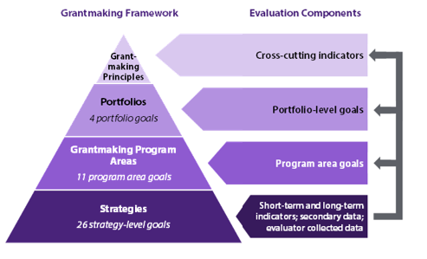

California HealthCare Foundation - Shifts in Evaluation & Learning
 | Before | After | How
What? | Grants & Projects | Strategy | Focus and prioritize evaluation efforts.  - Initiatives: outcomes  - Grants: process measures and outputs
When? | Retrospective | Ongoing | Establish metrics at the beginning of initiatives. Use to track progress and identify course corrections in an ongoing way.
Who? | Narrow audience (internal) | Broader audience  (internal) | Re-frame Results Reports as reflective, rather than descriptive, exercise.
How? | One-size-fits-all | Flexible & tailored | Allow flexibility in Results Report format.

Insights

- It’s about the thinking…not the numbers
- Audience, audience, audience
- Ongoing process
- Collaboration across departments
- Intersection of framework and process

For more information

AEA eLibrary: http://bit.ly/1MyRiSC

Jamie Schenker  Project Manager, Evaluation & Organizational Learning  JSchenker@Calwellness.org  Twitter: @js_calwellness | Rosanna Tran  Learning & Evaluation Officer  rtran@chcf.org  Twitter: @rtranCHCF

