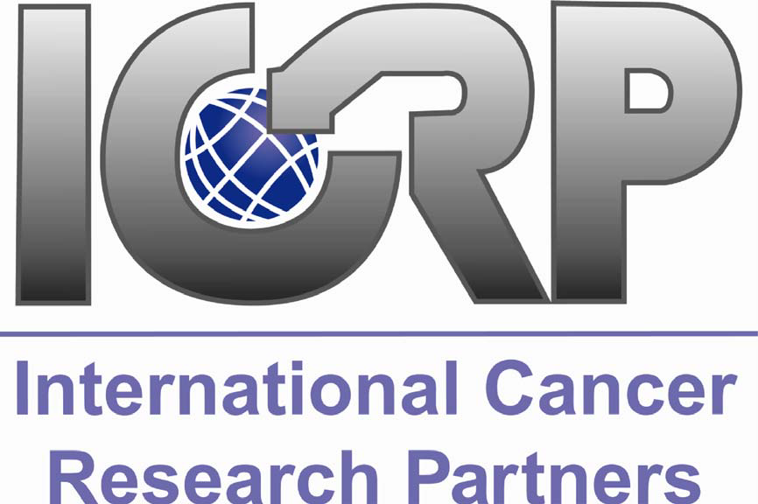

EVALUATING CAREER DEVELOPMENT AWARDS LESSONS LEARNED AND RECOMMENDATIONS FROM THE INTERNATIONAL CANCER RESEARCH PARTNERS

A PROJECT OF THE ICRP RESEARCH OUTCOMES SUBCOMMITTEE

FINAL JULY 2008

i

EXECUTIVE SUMMARY

INTRODUCTION & BACKGROUND

The International Cancer Research Partnership (ICRP) was initiated in 2000 when several organizations
involved in funding cancer research joined together to classify their research portfolios in a common
manner and maximize the benefits of the global investment in cancer research. Today, the ICR Partners
has grown to include 49 cancer funding organizations from the United States, Canada, and throughout
the United Kingdom. The mission of the ICR Partners is to enhance the impact of research to benefit all
individuals affected by cancer through global collaboration and strategic coordination of research. For
more information, see the ICRP website at www.cancerportfolio.org

The ICRP Outcomes Subcommittee was initiated in May 2006 at the Annual Meeting of the ICR Partnership with the goal of identifying and/or developing best practices for capturing, reflecting, and evaluating research outcomes.

OBJECTIVES

The objectives of this project are to:
1. Identify and synthesize what the ICR Partners and others have done to evaluate their career development awards.
2. Identify common methods and measures used in these evaluation studies.
3. Identify trends in the findings from evaluation studies
4. Develop recommendations for best practices to evaluate career development awards.
5. Test out the utility of comparing evaluation studies across cancer funding organizations to identify emerging outcome trends.

METHODS

The leader of the ICRP Outcomes subcommittee conducted interviews with staff from ICR Partners to better understand their current approaches to evaluating and tracking outcomes from their funded grants. Then Partners submitted copies of both published and non-published evaluation studies for the committee’s review. Additional literature searches were performed which identified evaluation studies conducted by cancer funding organizations not part of ICRP.

Committee members conducted a thorough document review and followed-up with staff to clarify methods or findings. Common and novel methods and measures were identified. Key findings were compiled and compared across award mechanisms. The committee reviewed all available data, identified emerging trends among reported outcomes and compiled best practices. In total, seventeen evaluation studies are included in this report: seven assessing outcomes from predoctoral awards, six postdoctoral award evaluations, and four studies of new investigator/transition awards.

Emerging Outcome Trends
Looking across all evaluation studies included in this report, we attempted to identify trends in measurable outcomes for cancer research career development awards. Given the data from the studies included in this report, we identified the following median values for the outcomes measures included:

Predoctoral Awards
• 70% of grantees reported satisfaction with graduate school;
• 94 % reported satisfaction with their research experience;
• 68-92% reported career gains (enhanced job prospects, acquiring transferable skills);
• 82% published at least one paper from their funded research;
• 70% stayed in research (either in their funded field or related field); and
• 48% leveraged additional funding (either themselves or their mentor/colleagues).

Postdoctoral Awards
• 46-66% reported career gains (increased self-confidence, increased independence, and helped attain faculty position/equivalent)
• 91% published at least one paper from their funded research;
• 81% remained in the funded field/in research;
• 59% leveraged additional funding (either for themselves or their mentor/colleagues).

New Investigator/Transition Awards
• 74% published at least one paper from their funded research;
• 89% remained in the funded field/research;
• 78% leveraged additional funding.

CONCLUSIONS AND RECOMMENDATIONS

Evaluating the outcomes of cancer research funding is a relatively new field that faces many challenges. The small number of available evaluation studies provides little data and experience to draw conclusions, set benchmarks, and determine best practices. However, funding agencies are increasingly under pressure to demonstrate the effectiveness and impact of their funding strategies. The efforts of the International Cancer Research Partners to share information and coordinate evaluation efforts is essential to gain a better understanding of the best way to track and evaluate outcomes from funding cancer research.

ICRP Recommendations
The ICRP Outcomes Committee makes the following recommendations:
- Encourage Partners to replicate part or all of an evaluation study conducted by another Partner.
- Encourage Partners to collaborate with one another to design and conduct evaluation studies.
- Sponsor a multi-partner/ ICRP endorsed evaluation study.
- Develop an iterative process of developing baseline standards by using existing data to create an initial baseline (benchmark), and then revising this standard as more studies are completed/incorporated into the analysis
- Develop a guide on conducting evaluation studies for career development awards including a template survey instrument questions and a survey instrument dictionary that provides the study design definition, the purpose(s) addressed by the study method, and known limitations or caveats to the study method.

Recommendations for Best Practices
Best practices included here are gleaned from evaluation reports and the experiences of the staff interviewed from this project. More details can be found in the body of this report.
- Perform systematic, on-going review of grants.
- Keep detailed records of grants and grantees.
- Define goals of the evaluation study and tailor to appropriate award type.
- Effort should be proportional to the overall value of the evaluation study.
- Careful planning ahead can determine usefulness of resulting report and the need/uses of the report should determine metrics.
- Each stage of training/career development should be evaluated with appropriate measures.
- When performing bibliometric analyses, primary research articles must be reviewed and verified to determine specific contributions and funding sources.
- Studies should be planned so that the results can be operationalized and improve granting program, not just an intellectual exercise.
- Collect a variety of data types: process and outcomes, quantitative and qualitative, short- and long-term.

