

**Maximizing the Impact of STEM Outreach (MISO)**

**Student Survey**

|  |
| --- |
|  |

**Background**The Maximizing the Impact of STEM Outreach (MISO) project at NCSU is an I3 NSF funded project. The purpose of MISO is to creatively integrate longitudinal evaluation with innovation within NC State’s K-12 STEM outreach programs. The MISO student survey was created to help MISO project partners collect and analyze data with regards to student STEM attitudes, interest in STEM careers, and 21st Century learning skills.

All MISO surveys are administered by MISO project staff and may be accessed via a free online surveying system. After the survey has been completed by program participants during each survey window, a report (along with the raw data) is provided to the project coordinator upon request.

**Appropriate Uses**The MISO Student Survey is intended to measure the changes in STEM attitudes and beliefs among students participating in various NCSU outreach programs. It provides information to help MISO project partners to make decisions about possible changes to their program. Specifically, project partners may use the MISO student data to complete evaluation and research activities. In addition to specific project data, the survey data are aggregated across all MISO project partners in an effort to show the effect of NCSU STEM outreach projects across campus.

**Data and Reporting**MISO collects *perceptive data* (what respondents think or feel) about their STEM attitudes, efficacy, and beliefs. Responses are analyzed through the online system and each report provides a picture of participants’ beliefs as a whole, presented as frequencies and percentages of responses to all items, and as bar chart representations of those values.

**Interpreting the Data**

Interpretation can be made at the individual item level but is more powerful at the construct (factor) level. There are three distinct sections to the pilot student survey: Stem Attitudes (subsections: Engineering, Math, and Science Attitudes), 21st Century Learning Skills, and STEM Career Interests. The STEM attitudes section was derived from a survey developed by Ekrut and Marx (2005) as part of an evaluation focusing on Women and Engineering. The STEM Career Interest section was adapted from the Occupational Outlook Handbook from the Bureau of Labor Statistics (<http://www.bls.gov/oco/>). Lastly, the 21st Century Learning section was developed at the Friday Institute as part of the North Carolina Student Learning Conditions Survey.

Survey data presented in this report is simply listed in the order in which the survey items were given to respondents; however, statistical analyses at the conclusion of the pilot period will determine the final factor structure. Future reports will present the data via their respective constructs.

The MISO Student Survey Response Scale for STEM Attitudes and 21st Century Learning Skills:

|  |  |  |  |  |  |
| --- | --- | --- | --- | --- | --- |
| **Strongly Disagree** | **Somewhat Disagree** | **Neither Agree nor Disagree** | **Somewhat Agree** | **Strongly Agree** | **I don’t Know** |

**Examples**

In the first profile, most respondents either “Strongly Agree” or “Agree” with the statement in the survey item. Since this item is worded positively, it is reasonable to infer that most students enjoy this type of task and program coordinators could build this type of task into their STEM outreach program.

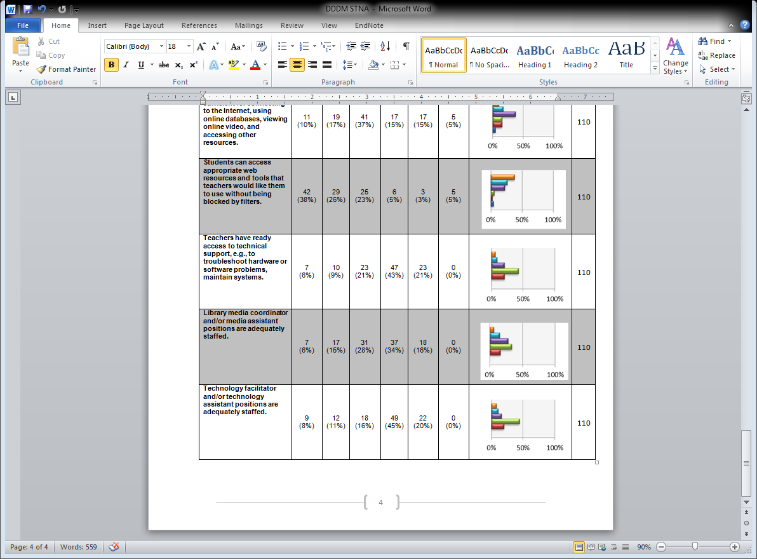

In the second profile, a large number of respondents report that they “Do Not Know” about the usefulness of science in their future career aspirations which indicates that they do not have enough information to respond to the statement. This suggests that a large portion of the students are not fully informed about this area, or that they do not have access to some of the information necessary to respond. In this case, gathering additional information about why the respondents are unsure or informed might prove helpful.

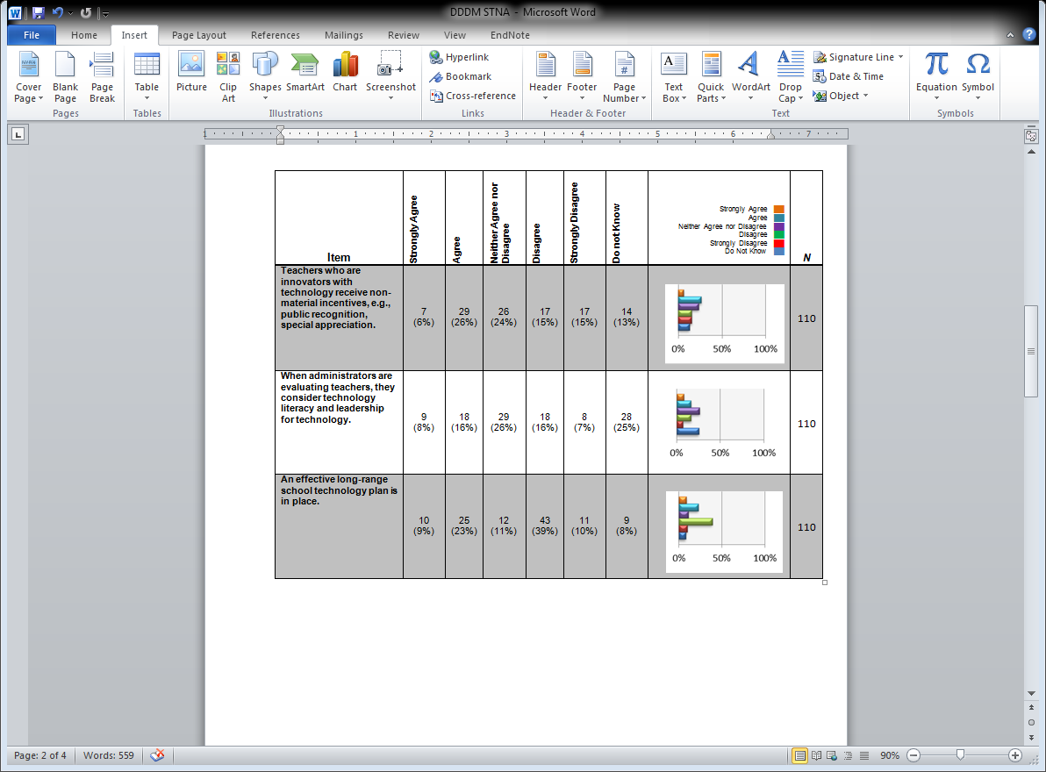

In the third profile, more students “Agree” with the statement, than “Disagree” with it; however, this profile suggests that substantial disagreement exists within students in the program, making this an area of concern for program coordinators. Few chose “Do Not Know,” suggesting that awareness in this area is good. Again, this indicates a need to gather additional data.



This fourth and final profile represents students who are very mixed in their thinking about the area examined. Additional information will be required to determine why people feel the way that they do about issues relating to this item. It is difficult to make any specific inferences, but it is obvious that this is an area of concern**.**

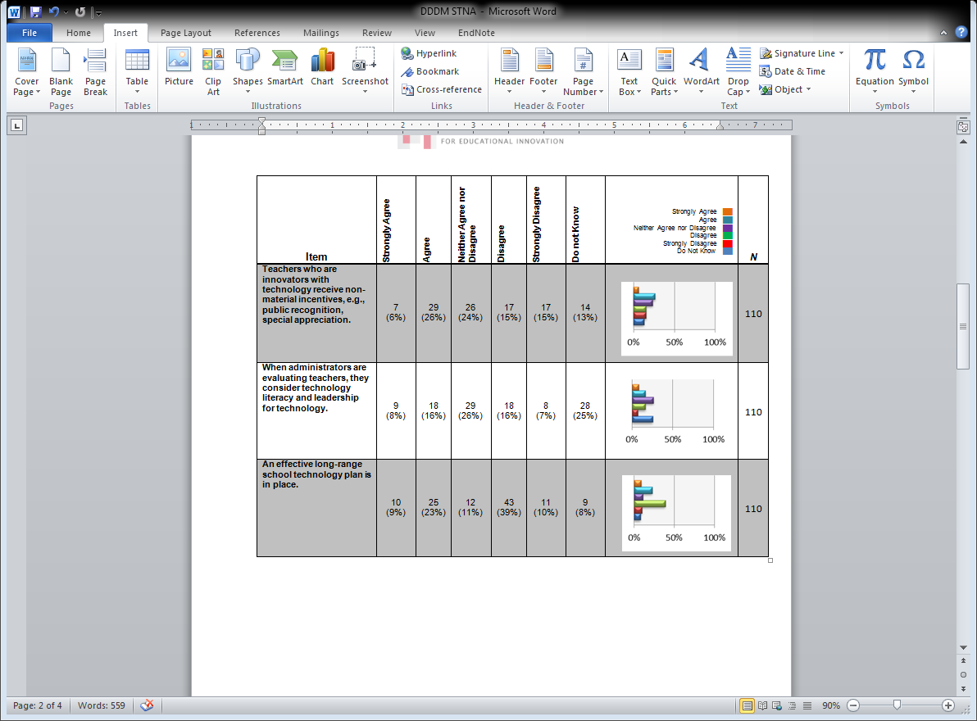

**The remaining pages contain an actual MISO report.**

**MISO Pilot Student Survey**

|  |  |  |  |  |  |  |  |  |
| --- | --- | --- | --- | --- | --- | --- | --- | --- |
| **Item** | **Strongly Disagree** | **Somewhat Disagree** | **Neither Agree nor Disagree** | **Somewhat Agree** | **Strongly Agree** | **I do not Know** | **Strongly Disagree ██  Somewhat Agree ██  Neither Agree nor Disagree ██ Somewhat Agree ██  Strongly Agree ██  Do Not Know ██** | ***N*** |
| **Engineering Attitudes** | | | | | | | | |
| A degree in engineering will allow me to obtain a well-paying job. | 1 (1%) | 1 (1%) | 3 (4%) | 18 (26%) | 46 (66%) | 1 (1%) |  | 70 |
| I am not interested in any career that uses math and science. | 55 (79%) | 6 (9%) | 6 (9%) | 2 (3%) | 1 (1%) | 0 (0%) |  | 70 |
| I like fixing broken appliances. | 8 (12%) | 6 (9%) | 12 (17%) | 26 (38%) | 16 (23%) | 1 (1%) |  | 69 |
| At the science museum, I like the exhibits on robotics. | 0 (0%) | 6 (9%) | 13 (19%) | 12 (17%) | 37 (54%) | 1 (1%) |  | 69 |
| A degree in engineering will allow me to obtain a job that I like doing. | 1 (1%) | 2 (3%) | 5 (7%) | 15 (22%) | 45 (66%) | 0 (0%) |  | 68 |
| I have no interest in helping design a space station. | 29 (41%) | 16 (23%) | 10 (14%) | 5 (7%) | 7 (10%) | 3 (4%) |  | 70 |
| Engineering skills will allow me to improve society. | 0 (0%) | 0 (0%) | 7 (10%) | 19 (27%) | 42 (60%) | 2 (3%) |  | 70 |
| A degree in engineering will give me the kind of lifestyle I want. | 0 (0%) | 4 (6%) | 7 (10%) | 14 (20%) | 37 (54%) | 7 (10%) |  | 69 |
| I am interested in designing better artificial limbs. | 17 (25%) | 8 (12%) | 21 (30%) | 13 (19%) | 9 (13%) | 1 (1%) |  | 69 |
| I would like to learn how to make safer cosmetics. | 24 (35%) | 11 (16%) | 18 (26%) | 7 (10%) | 9 (13%) | 4 (6%) |  | 69 |
| Engineering interests me because I like to think about solving technical problems. | 2 (3%) | 3 (4%) | 4 (6%) | 24 (35%) | 35 (51%) | 1 (1%) |  | 69 |
| I am not interested in what makes machines work. | 48 (69%) | 14 (20%) | 4 (6%) | 3 (4%) | 1 (1%) | 0 (0%) |  | 70 |
| **Math Attitudes** | | | | | | | | |
| Math is a worthwhile, necessary subject. | 1 (1%) | 0 (0%) | 3 (4%) | 15 (21%) | 51 (73%) | 0 (0%) |  | 70 |
| Math is not important for my life. | 60 (86%) | 6 (9%) | 4 (6%) | 0 (0%) | 0 (0%) | 0 (0%) |  | 70 |
| Math has been my worst subject. | 57 (81%) | 6 (9%) | 2 (3%) | 4 (6%) | 1 (1%) | 0 (0%) |  | 70 |
| I see math as something I won’t use very often when I get out of high school. | 57 (81%) | 9 (13%) | 2 (3%) | 0 (0%) | 2 (3%) | 0 (0%) |  | 70 |
| I would consider choosing a career that uses math. | 0 (0%) | 1 (1%) | 6 (9%) | 16 (23%) | 47 (67%) | 0 (0%) |  | 70 |
| I study math because I know how useful it is. | 0 (0%) | 2 (3%) | 5 (7%) | 16 (23%) | 46 (67%) | 0 (0%) |  | 69 |
| Math is hard for me. | 39 (56%) | 15 (21%) | 10 (14%) | 5 (7%) | 1 (1%) | 0 (0%) |  | 70 |
| I will need a good understanding of science for my future work. | 0 (0%) | 0 (0%) | 5 (7%) | 16 (23%) | 47 (67%) | 2 (3%) |  | 70 |
| I am not the type to do well in math. | 53 (77%) | 8 (12%) | 5 (7%) | 3 (4%) | 0 (0%) | 0 (0%) |  | 69 |
| I can handle most subjects well, but I cannot do a good job with math. | 54 (77%) | 9 (13%) | 5 (7%) | 2 (3%) | 0 (0%) | 0 (0%) |  | 70 |
| I am sure I could do advanced work in math. | 0 (0%) | 3 (4%) | 3 (4%) | 17 (24%) | 46 (66%) | 1 (1%) |  | 70 |
| I can get good grades in math | 0 (0%) | 1 (1%) | 3 (4%) | 5 (7%) | 61 (87%) | 0 (0%) |  | 70 |
| I am not good in math. | 57 (81%) | 8 (11%) | 4 (6%) | 1 (1%) | 0 (0%) | 0 (0%) |  | 70 |

|  |  |  |  |  |  |  |  |  |
| --- | --- | --- | --- | --- | --- | --- | --- | --- |
| **Science Attitudes** | | | | | | | | |
| I am sure of myself when I do science. | 1 (1%) | 2 (3%) | 7 (10%) | 18 (26%) | 41 (59%) | 0 (0%) |  | 69 |
| I would consider a career in science. | 1 (1%) | 2 (3%) | 6 (9%) | 19 (27%) | 42 (60%) | 0 (0%) |  | 70 |
| I do not expect to use much science when I get out of school. | 47 (67%) | 14 (20%) | 6 (9%) | 2 (3%) | 0 (0%) | 1 (1%) |  | 70 |
| Knowing science will help me earn a living. | 0 (0%) | 1 (1%) | 5 (7%) | 19 (28%) | 42 (61%) | 2 (3%) |  | 69 |
| I will need science for my future work. | 0 (0%) | 2 (3%) | 8 (11%) | 17 (24%) | 42 (60%) | 1 (1%) |  | 70 |
| I know I can do well in science. | 0 (0%) | 0 (0%) | 3 (4%) | 12 (17%) | 53 (77%) | 1 (1%) |  | 69 |
| Science will not be important to me in my life’s work | 44 (63%) | 14 (20%) | 7 (10%) | 1 (1%) | 1 (1%) | 3 (4%) |  | 70 |
| Science is a worthwhile, necessary subject. | 0 (0%) | 1 (1%) | 5 (7%) | 11 (16%) | 53 (76%) | 0 (0%) |  | 70 |
| I can handle most subjects well, but I cannot do a good job with science. | 54 (77%) | 9 (13%) | 7 (10%) | 0 (0%) | 0 (0%) | 0 (0%) |  | 70 |
| I am sure I could do advanced work in science. | 0 (0%) | 1 (1%) | 8 (11%) | 15 (21%) | 42 (60%) | 4 (6%) |  | 70 |

|  |  |  |  |  |  |  |  |  |
| --- | --- | --- | --- | --- | --- | --- | --- | --- |
| **21st Century Learning** | | | | | | | | |
| I am confident I can lead others to accomplish a goal. (leadership) | 1 (1%) | 0 (0%) | 6 (9%) | 30 (43%) | 33 (47%) | 0 (0%) |  | 70 |
| I am confident I can encourage others to do their best. (leadership) | 1 (1%) | 0 (0%) | 6 (9%) | 18 (26%) | 44 (63%) | 1 (1%) |  | 70 |
| I am confident I can make moral decisions. (ethics) | 0 (0%) | 0 (0%) | 4 (6%) | 23 (33%) | 42 (60%) | 1 (1%) |  | 70 |
| I am confident I can produce high quality work. (personal productivity) | 0 (0%) | 0 (0%) | 2 (3%) | 17 (24%) | 51 (73%) | 0 (0%) |  | 70 |
| I am confident I can act responsibly. (personal responsibility) | 0 (0%) | 1 (1%) | 3 (4%) | 9 (13%) | 57 (81%) | 0 (0%) |  | 70 |
| I am confident I can complete tasks without being told exactly what to do. (self-direction) | 0 (0%) | 2 (3%) | 9 (13%) | 28 (40%) | 31 (44%) | 0 (0%) |  | 70 |
| I am confident I can respect the differences of my peers. (social responsibility) | 0 (0%) | 1 (1%) | 2 (3%) | 14 (20%) | 52 (74%) | 1 (1%) |  | 70 |
| I am confident I can help my peers. (social responsibility) | 0 (0%) | 1 (1%) | 5 (7%) | 14 (20%) | 49 (70%) | 1 (1%) |  | 70 |
| I am confident I can think about others when making decisions. (social responsibility) | 0 (0%) | 1 (1%) | 4 (6%) | 25 (36%) | 40 (57%) | 0 (0%) |  | 70 |
| I am confident I can accept others’ ideas even if they differ from mine.(adaptability and flexibility) | 0 (0%) | 2 (3%) | 3 (4%) | 25 (36%) | 40 (57%) | 0 (0%) |  | 70 |
| I am confident I can make changes when things do not go as planned. (adaptability and flexibility/initiative and self-direction) | 2 (3%) | 0 (0%) | 3 (4%) | 21 (30%) | 43 (61%) | 1 (1%) |  | 70 |
| I am confident I can set my own learning goals. (setting goals) | 1 (1%) | 1 (1%) | 6 (9%) | 17 (24%) | 43 (61%) | 2 (3%) |  | 70 |
| I am confident I can manage my time wisely when working on my own. (initiative and self-direction) | 1 (1%) | 4 (6%) | 8 (11%) | 25 (36%) | 32 (46%) | 0 (0%) |  | 70 |
| When I have many assignments, I can choose which ones need to be done first. (initiative/self-direction/prioritizing) | 1 (1%) | 1 (1%) | 7 (10%) | 18 (26%) | 43 (61%) | 0 (0%) |  | 70 |
| I am confident I can work well with students from different backgrounds. (people skills – social/cross-cultural skills) | 1 (1%) | 1 (1%) | 3 (4%) | 13 (19%) | 51 (73%) | 1 (1%) |  | 70 |
| I am confident I can work well with other students in a small group.(people skills) | 1 (1%) | 0 (0%) | 2 (3%) | 15 (21%) | 52 (74%) | 0 (0%) |  | 70 |