Getting in Synch
Martha Merson, Project Director, TERC

The purpose of the evaluation was to learn to what extent Statistics for Action, a set of materials and resources and training developed by math educators with input from environmental organizers, could increase numeracy among environmental organizers and the community members they serve. For this generally unpopular content in an unusual context, the author describes project and evaluation design choices that worked, and those that didn’t.

Project Background
The Statistics for Action (SfA) project and its evaluation began in late 2008 with educational researchers at TERC in leadership roles. Four environmental organizations active in 13 states led implementation and had input in the product development. The four-year project, funded by the National Science Foundation (DRL0812954), was designed to increase the capacity of environmental organizers to build opportunities for numeracy learning among the community members they serve. The goals of this project were to develop materials, provide training to organizers on their use, institutionalize them in environmental organizations, research how they were used, and evaluate their impact. Each partner organization had its own history, board, director and several organizers. Prior to funding, they all agreed to the funding and obligations of participation, e.g., to use the materials, attend training, and incorporate SfA into their new staff orientations. project design. They all embraced a proactive stance toward environmental health; a commitment to environmental justice; and a commitment to empowering citizens and residents. Yet how they structured their work with community members varied, as did how they incorporated SfA into their work and their level of commitment to the project. Turnover rates for three organizations were so high that two years after an initial two-day training, only four of the twelve participants are still at the same organization and only one holds the same job.

TERC educators envisioned three distinct audiences for their work—environmental organizers, community group members, and members of the public. They defined numeracy as the knowledge and skills required to effectively manage and respond to the mathematical demands of diverse situations (Tout and Schmitt, 2002). TERC staff worked closely with the evaluation team of Arbor Consulting Partners who conducted a formative and summative evaluation. The project leaders at TERC, in consultation with their primary partner, Toxics Action Center, proposed to produce materials for use by community members and environmental organizers through an iterative process. Project leaders and evaluators anticipated that the materials and training would have a measurable impact on environmental organizers and community members, in terms of their knowledge, skills, attitude, engagement, and behavior, individually and/or collectively.

Key Considerations Influencing Project Plan and Evaluation Methods
Conversations with directors at partner organizations highlighted the needs and backgrounds of community organizers and the community members they serve. The project director carved out the territory SfA should cover, as well as areas where SfA should tread lightly or not at all. Given these key considerations, TERC educators and evaluators had to think and plan carefully about what data made sense to collect. A high priority, for example, was to avoid contributing to negative attitudes toward math that tend to be prevalent among adults. This section describes the key considerations in more detail, including: prevalent attitudes toward math, participants’ expectations, and appropriate methodology for informal settings.

• Math tests cause anxiety
Realizing that math is often shunned and a trigger for panic and embarrassment, project leaders decided that assessing participants’ math knowledge directly (with pencil and paper tests) would be inadvisable. The project leaders and evaluators crafted a baseline survey that sought to characterize the pedagogical repertoire for environmental organizers and determine relevant skills for community members. Neither group would be tested on math content knowledge, though both groups would be asked about it in surveys and focus groups. The surveys were designed to set a tone that welcomed people of all skill levels to the project.

• Informal educators’ default is to avoid math
Previous evaluations of NSF-funded projects with librarians and afterschool workers as conduits for math learning in informal settings have shown that without appropriate materials, a large majority of informal educators avoid math. Similarly, environmental organizers of partner groups tended to shy away from teaching science and math content (mixinginmath.terc.edu/reports, accessed October 2012). The quote below from an organizer illustrates this discomfort with mathematics.
Really, I am not sure about this because I have generally avoided it before now. I usually assume that the time involved in digging through data or numbers would be so lengthy …. It is daunting … I do have a lot of discussions that are issue-based when it comes to science, I just typically avoid the numbers and the math (Year 1 Report).
Even those who grasped math concepts themselves and valued their use in environmental organizing work expressed reluctance to take on the role of teacher.
I don’t know the best way to teach others, because I figure things out intuitively, and I don’t always know how to explain them (Year 1 Report).

• Opportunities abound for building and assessing numeracy of adults in informal settings
Though research on math learning tends to focus on children in school settings, adults are an important audience. The National Science Foundation invests in informal STEM learning as part of its mission to increase citizens’ understanding of science, math, technology, and engineering. Time spent in classrooms pales in comparison with the time people spend outside of school. American adults spend over 80% of lifetime waking hours outside schools (Stevens & Bransford, 2007). In recent studies Falk and Dierking have sough to learn how adults add to their knowledge base (Falk et al, 2007). Regarding their science knowledge, adults cite educational TV, garden clubs, science museum exhibits, and other leisure time pursuits. No similar research has been done on adults’ math gains outside of school or workplace settings. However, in the context of community meetings on local environmental issues, adults frequently gather and form groups to address concerns about local environmental threats. Such settings are rife with opportunities to expand and deepen numeracy. The potential for learning math and science associated with environmental regulation, sampling, air quality, bioaccumulation, health risks, and more is high.

• The potential for environmental education alongside environmental organizing is strong.
Environmental organizers typically focus on adults’ skill development in fundraising, group-building, running meetings, and clarifying goals toward winning a campaign. They did not consider the role they might have as math and science educators prior to working with SfA, in spite of their interest in teaching community members new skills. TERC math educators believed organizers could facilitate math learning and saw local environmental campaigns as a way to engage a hard-to-reach audience—particularly people in low-income communities of color who lack the funds to go to science museums, or even the time to attend free programs like GED classes.

• Success reinforces doing math
Evaluators of TERC’s other projects with informal educators have found that with accessible, colorful materials, adults with minimal math background can foster math learning for children. Positive experiences facilitating math activities have proven motivating, leading afterschool educators and librarians to include more math activities in their work with children (mixinginmath.terc.edu/reports). SfA staff believed that similarly produced materials and activities would motivate and foster learning with adults as well.

Design Flaws and Promising Practices
The evaluation demonstrated that SfA achieved its general goals, creating guides and activities, engaging hundreds of community members and reaching thousands of members of the public, in spite of the fact that some of the assumptions at the core of the project and evaluation design didn’t hold true. In fact, there were a number of factors that made it difficult to assess program impact on community group members via quantitative data collection methods, including: changing membership of community groups, the challenge for organizers of incorporating SfA into an entire campaign, the choice of some organizers to use SfA concepts without “naming” them in a way that evaluators could identify. In several organizations, many who received SfA training never implemented use of the materials and approaches. Moreover, the staff turnover rate among the participating environmental organizers was relatively high, and a number of trained organizers left their jobs before using SfA consistently in community group settings.

Nonetheless, evaluators found that through focus groups, interviews and participant observation, community members were able to identify specific ways in which SfA affected their knowledge about math and statistics, their attitudes towards incorporating this knowledge into their environmental initiatives, and their skills in presenting numbers and statistics. Evaluation data is more definitive about the impact on environmental organizers, and while the n is small, the data is rich and deep. In spite of challenges, this research has yielded important lessons for STEM educators seeking to collaborate with environmental organizers in informal settings. It has also reaped lessons learned for evaluators seeking to capture the impact of an informal math intervention on environmental organizers, and raised important issues for educators seeking to expand opportunities for math teaching and learning through their work with environmental organizers. Getting in synch, assessing the culture and making appropriate judgments about data collection strategies was crucial to the project demonstrating its value.

As noted above, key considerations guided the project and evaluation designs. Certain assumptions were made based on our project design. Actual implementation, in response to participant needs, looked different than expected. The table below outlines how the methods aligned with assumptions and how those assumptions played out, proving valuable for data collection but also producing disappointing expectations.

Project components & activities related to assumptions | Evaluation Method | Reality Intrudes: Design Flaws () and Promising Practices ()
Baseline needed  Over time, environmental organizers and community members would build confidence, skills, and knowledge | Method planned: pre- and post-surveys, annual interviews with organizers | Instruments elicited attitudes toward math and avoided putting adults on the spot to perform math, however, associated consent requirements were off-putting
Test results & outreach  Community members receive and use test results in their outreach. | Method planned: observation | All groups didn’t get test result data
Teaching takes off, informed by training, capitalizing on SfA materials  Environmental organizers would, with the right materials and training, feel comfortable facilitating math learning. | Method planned: observation, survey questions of organizers, e.g., activities and teaching strategies used  Project workaround: Offered more coaching, revised materials, and opportunities for peers to share successes  Eval work around: Interviews probed for effects of SfA on organizers’ work more broadly | Environmental organizers resisted using activities that felt like school and called for intensive set-up. They preferred to facilitate SfA activities at opportune moments and at conferences, where community group members had an expectation of learning new content and skills.
Regular Meetings  That environmental organizers would meet regularly with community groups over time, allowing evaluators to assess changes over time. | Method planned: Pre- and post-surveys of community members who had multiple experiences with SfA.  Eval work around: Instituted ½ page reaction sheet used immediately after SfA activities | Meetings fluctuated in frequency and attendance. External factors suddenly changed group priorities; groups disbanded without much notice for evaluators. Environmental organizers didn’t feel comfortable inserting SfA into the agendas.
Artifacts  Community members would want to design flyers, ads, or banners that would give visibility to their numerical claims | Method planned: Analysis of artifacts connected to SfA activities led by environmental organizers  Eval work around: Organizers tracked products influenced by SfA and reported back | Only one group generated a flyer. Others had some written materials, but they weren’t a result of a group process, so few groups generated artifacts with a direct connection to SfA.
Group Reflection  Organizers and community group members would gather and reflect on SfA and their work | Method planned: Focus groups | This was among the most useful data collection strategies, aligning with the culture of partner organizations
Individual, community group member feedback  That gathering community member feedback after every use of SfA would be onerous | Method planned: Pre- and post surveys  Eval work around: Instituted ½ page reaction sheet used immediately after SfA activities | Participants quickly filled out ½ page forms. Due to ill health and other factors, bringing some groups back together after they had disbanded proved impossible.
Organizers expand their pedagogical strategies  Organizers would draw on a variety of facilitation strategies | Method planned: Hypothetical questions on pre- and post-surveys | Open-response format allowed for creativity; “check all that apply ” items provided insight into organizers’ ideas of appropriate pedagogy

Reflecting on Approaches: Four promising practices
Four approaches seemed well aligned with the mission of the organizers and goals of project leaders.
- TERC educators and evaluators were sensitive in the design to several factors. The survey intentionally framed questions to model an expansive definition of math, rather than assume a shared definition. Often people assume math is calculating an answer to a word problem or to a naked number problem with one right answer. Rather than asking, “I have the skills I need to help community group members with math,” instead, survey items gave the math context. For example, participants were asked to rate their agreement with statements like:

I have the skills I need to help community group members …
- Anticipate costs and fundraising needed to carry forward a campaign.
- Interpret toxicity levels, measurements and quantities in water, soil, and air quality reports.
- Interpret measurements and quantities in regulations.
- Understand data collection and sample size.
- Verify that results are reasonable.
- Gauge an appropriate level of precision.
- Use fractions, decimals, percents and/or ratios.
- Use powerful numbers in press releases and outreach.

2) Hypotheticals on facilitation strategies gave developers and evaluators a sense for how organizers were expanding their repertoire of math facilitation skills.

A community group receives an air quality report with the following entry:
Carcinogen Ug/m³
- Benzene 0.12
Someone in the group asks, “What does 0.12 mean?”

The answers could be compared to the Smart Moves for Math Facilitation that TERC educators promoted. Evaluators compared answers for organizers who responded to surveys on an annual basis. Organizers were asked to choose among a list of possible strategies. The project leaders could see that organizers would rely on an expanded set of strategies. The responses might indicate that their comfort level with and confidence in a variety of strategies increased.

Imagine you are leading a meeting in which you are helping community members understand the math involved in interpreting the toxicity levels in water, soil, or air quality reports. Which would you be most inclined to do?
- Explain the math involved clearly and logically
- Elicit an estimate
- Ask participants to figure it out themselves first and compare solution strategies with one another.
- Present a problem situation and ask pairs to work together on multiple solutions.
- Show how to plug numbers into a formula on a calculator or spreadsheet
- Provide a visual or supply manipulatives (such as cubes weighing a gram each)
- Ask people to draw the problem, then compare different people’s ideas
- Make an analogy or use a metaphor

3) During focus groups, evaluators posed open-ended questions relating SfA to environmental campaigns. Evaluators invited organizers and community group members to comment on the impact of the project. Evaluators kept the math central and connected to the organizers’ work.
- How has working on this project affected your perception of the role of math/science in your work?
- What if anything has changed for you?
- What stage are you at in terms of your work?
One organizer expressed trepidation before the first focus group with her community group, but quickly changed her opinion, citing its value for the group. Organizers who were enthusiastic about the project set a positive tone that was contagious and productive for the project.

4) Quick, ½ page evaluation forms with a campaign focus handed out and completed at the end of an SfA activity. These proved to be easy to implement and seemed to give everyone a sense of closure and accomplishment. Items emphasized participants’ engagement and attitude. For example, “Participating in this activity gives me more confidence to speak about this topic.” No one complained that these were burdensome and one organizer asked that the initial form be revised to add a question asking participants to say how the activity could be improved.
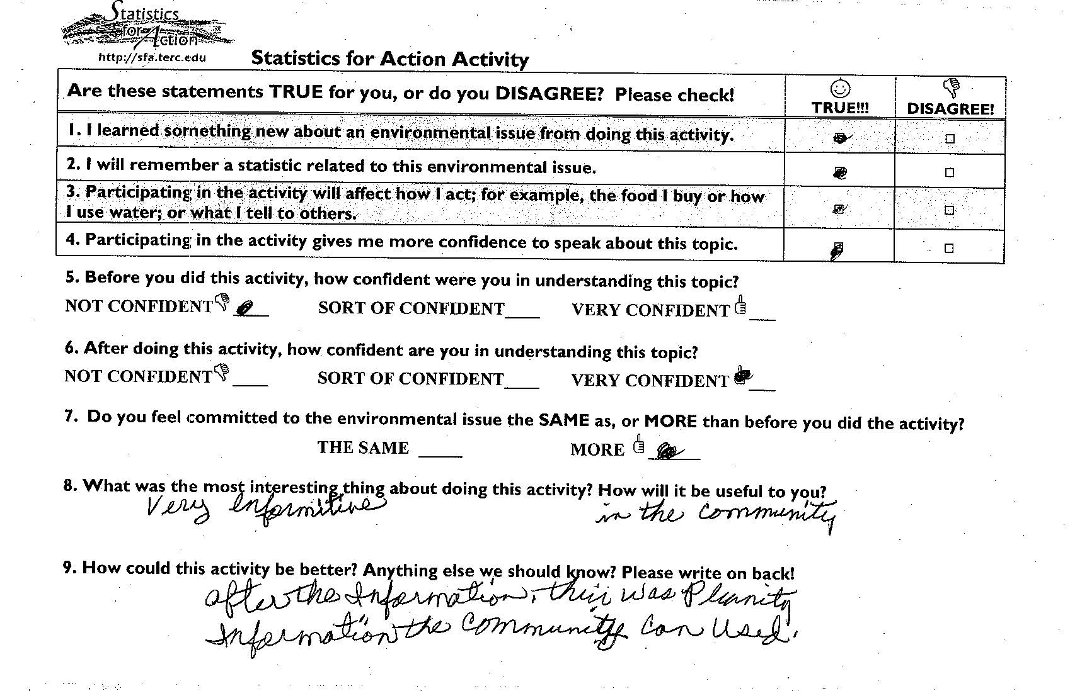

Reflections on Design Flaws, Features of Organizational Culture and Implications for Evaluation Design
TERC educators worked closely with their New England-based environmental organizational partner. Over time, they became aware of nuances in structures, policies, precedents, and stance toward environmental organizing that would have implications for the success of SfA. Environmental organizers of SfA’s main partner group are younger than the community members they serve. They often work 60 hours a week, fueled by a crisis mentality. Young organizers talk weekly with their supervisors. When they do present at a community meeting, they work from a scripted guide. Before presenting, they have participated in role-plays as community group members and facilitators, acting out these consultations before taking leadership in public. After presenting, they debrief with a peer or supervisor. Frequently they work most closely with a group leader or two in a community. They embraced SfA as part of this process. At the same time, they feel pressure to prove their worth and thus are invested in presenting themselves as having expertise to share. They resisted a pedagogy where people puzzled things out together slowly – the SfA style was less predictable than their highly-structured workshops, and risked undermining the facilitator’s perceived expertise.

Perhaps more attention early on to the culture of the environmental organizations would have led developers and evaluators to adjust their plans even more. With the help of the evaluation team, TERC educators eventually learned that before they (and educators like them) could fully leverage opportunities for expanding math and science learning, they would need to adjust their expectations and educational models. Most of these lessons learned may seem obvious now, but they bear documenting, and may prove useful particularly for a project that takes on a loaded topic like math teaching and learning for adults in a fast-paced, informal setting. In hindsight, time invested in understanding the organizers’ job descriptions, concerns, and the structures supporting them, educators, and evaluators could have allowed educators, evaluators, and environmental partners to be even more in synch.

Acknowledging these aspects of the culture of environmental organizers helped the project adjust its design in the following ways:
- Role-playing precedes facilitation of new content—SfA math activities were written with scenarios and workshops incorporated role-plays.
- Avoidance of data-driven arguments (job gains, property values, specific levels and risks)—materials stayed away from money-related math and highly technical risk assessment formulae so organizers could stay on familiar territory.
- Impulse to give info, to answer people’s questions—TERC educators began countering the impulse explicitly with tips for presenters, encouraging them to slow down, give opportunities for audience members to consider patterns, estimate a quantity, imagine a comparison, metaphor, or analogy.
- Impulse to give info, to answer people’s questions—Organizers valued checklists, principles, so SfA added materials with bulleted lists of principles to complement group activities. Organizers could preface activities with principles, thereby demonstrating their expertise and proving their value added.
- SfA’s original classroom-style model using multiple stations, with hands-on activities illustrating different concepts, each with heavy set-up, were downplayed for local gatherings in favor of facilitator-led, sitting-down, whole-group activities.

Evaluators then made a point of observing orientations and taking notes on role plays and the debrief of them. Evaluators added interviews of community members who played an active role in leading SfA or who used the SfA materials and approach. They dropped the post-survey for community members and conducted fewer observations than expected.

Though weekly meetings between organizers and their supervisors to strategize and intensive work with one or two community leaders in a community were frequent occurrences, the project did not find a way to capitalize on, characterize or measure the quality of one-on-one conversations as they related to math and science teaching and learning. Evaluators focused on observing mentoring in group settings, especially during training of new staff, and discussed this process in annual focus groups. While it may be useful to consider how to hone in on this relationship for future evaluations, observe this type of 1-1 training might not be practical for various reasons, e.g., issues related to comfort level of organizers, and likelihood of impacting outcome, budget implications.

Conclusion: Lessons learned
TERC educators learned an enormous amount during Statistics for Action. Evaluators and project leaders agree that where and how to look at informal math initiatives call for innovative, customized approaches to project and evaluation design. While it is hard to give up pre- and post-assessments and the desire to track impact over time on an intended audience, the lessons of this project point to the folly of holding onto such notions. Given the dearth of information on how adults expand their numeracy in out-of-school settings, evaluators may find that participants are more inclined to use what they know, are more confident about communicating what they know to others, but don’t necessarily report learning new math skills or content. Evaluators need to tailor instruments to elicit impact of this kind.

Attempts to contextualize questions, locate evaluation instruments when the work was happening, and focus on the organizers as agents of change paid off. The project needed ongoing adjustments to align its deliverables and evaluation to be in synch with participants’ mission and job descriptions. Evaluators could have leveraged the close relationships between environmental organizers and group leaders, between supervisors and organizers, as this was where conversations about implementation were regularly occurring. Instruments capturing participants’ response in the moment felt more in synch with the style of interaction than an effort to defer feedback and evaluation for a later date. Particularly with a new intervention in a minimally researched area, it makes more sense to include interviews, focus group questions, or survey items that invite participants to reflect on broader impact. SfA had a broader impact than expected, influencing a wider set of behaviors/repertoire than intended.

References Cited

Falk, J. et al (2007). Investigating Public Science Interest and Understanding: Evidence for the importance of free-choice learning. Public Understanding of Science, 16(4), 455-469.

Merson, M. et al (2008). Statistics for Action Annual Report. TERC: Cambridge, MA.

Stevens, R. & Bransford, J. (2007) Lifelong and Lifewide Learning Diagram. In Learning In and Out of School in These Environments: Life-long, life-wide, life-deep.. Seattle: UW Center for Multicultural Education and The LIFE Center.

Tout, D. Schmitt, MJ. (2002). The Inclusion of Numeracy in Adult Basic Education. Review of Adult Learning and Literacy. NCSALL: Cambridge, MA.

Note on language: “participants” is used to refer to community members and organizers. If comments pertain to one or the other audience, they are referred to by their role.

