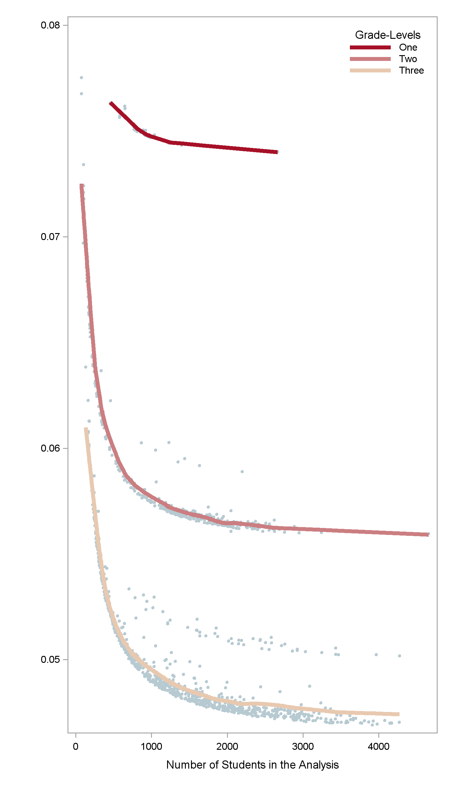

**The standard error of the school effect size is highly dependent on the number of grade-levels.**

**Standard**

**Error**

**Number of Students in the Analysis**

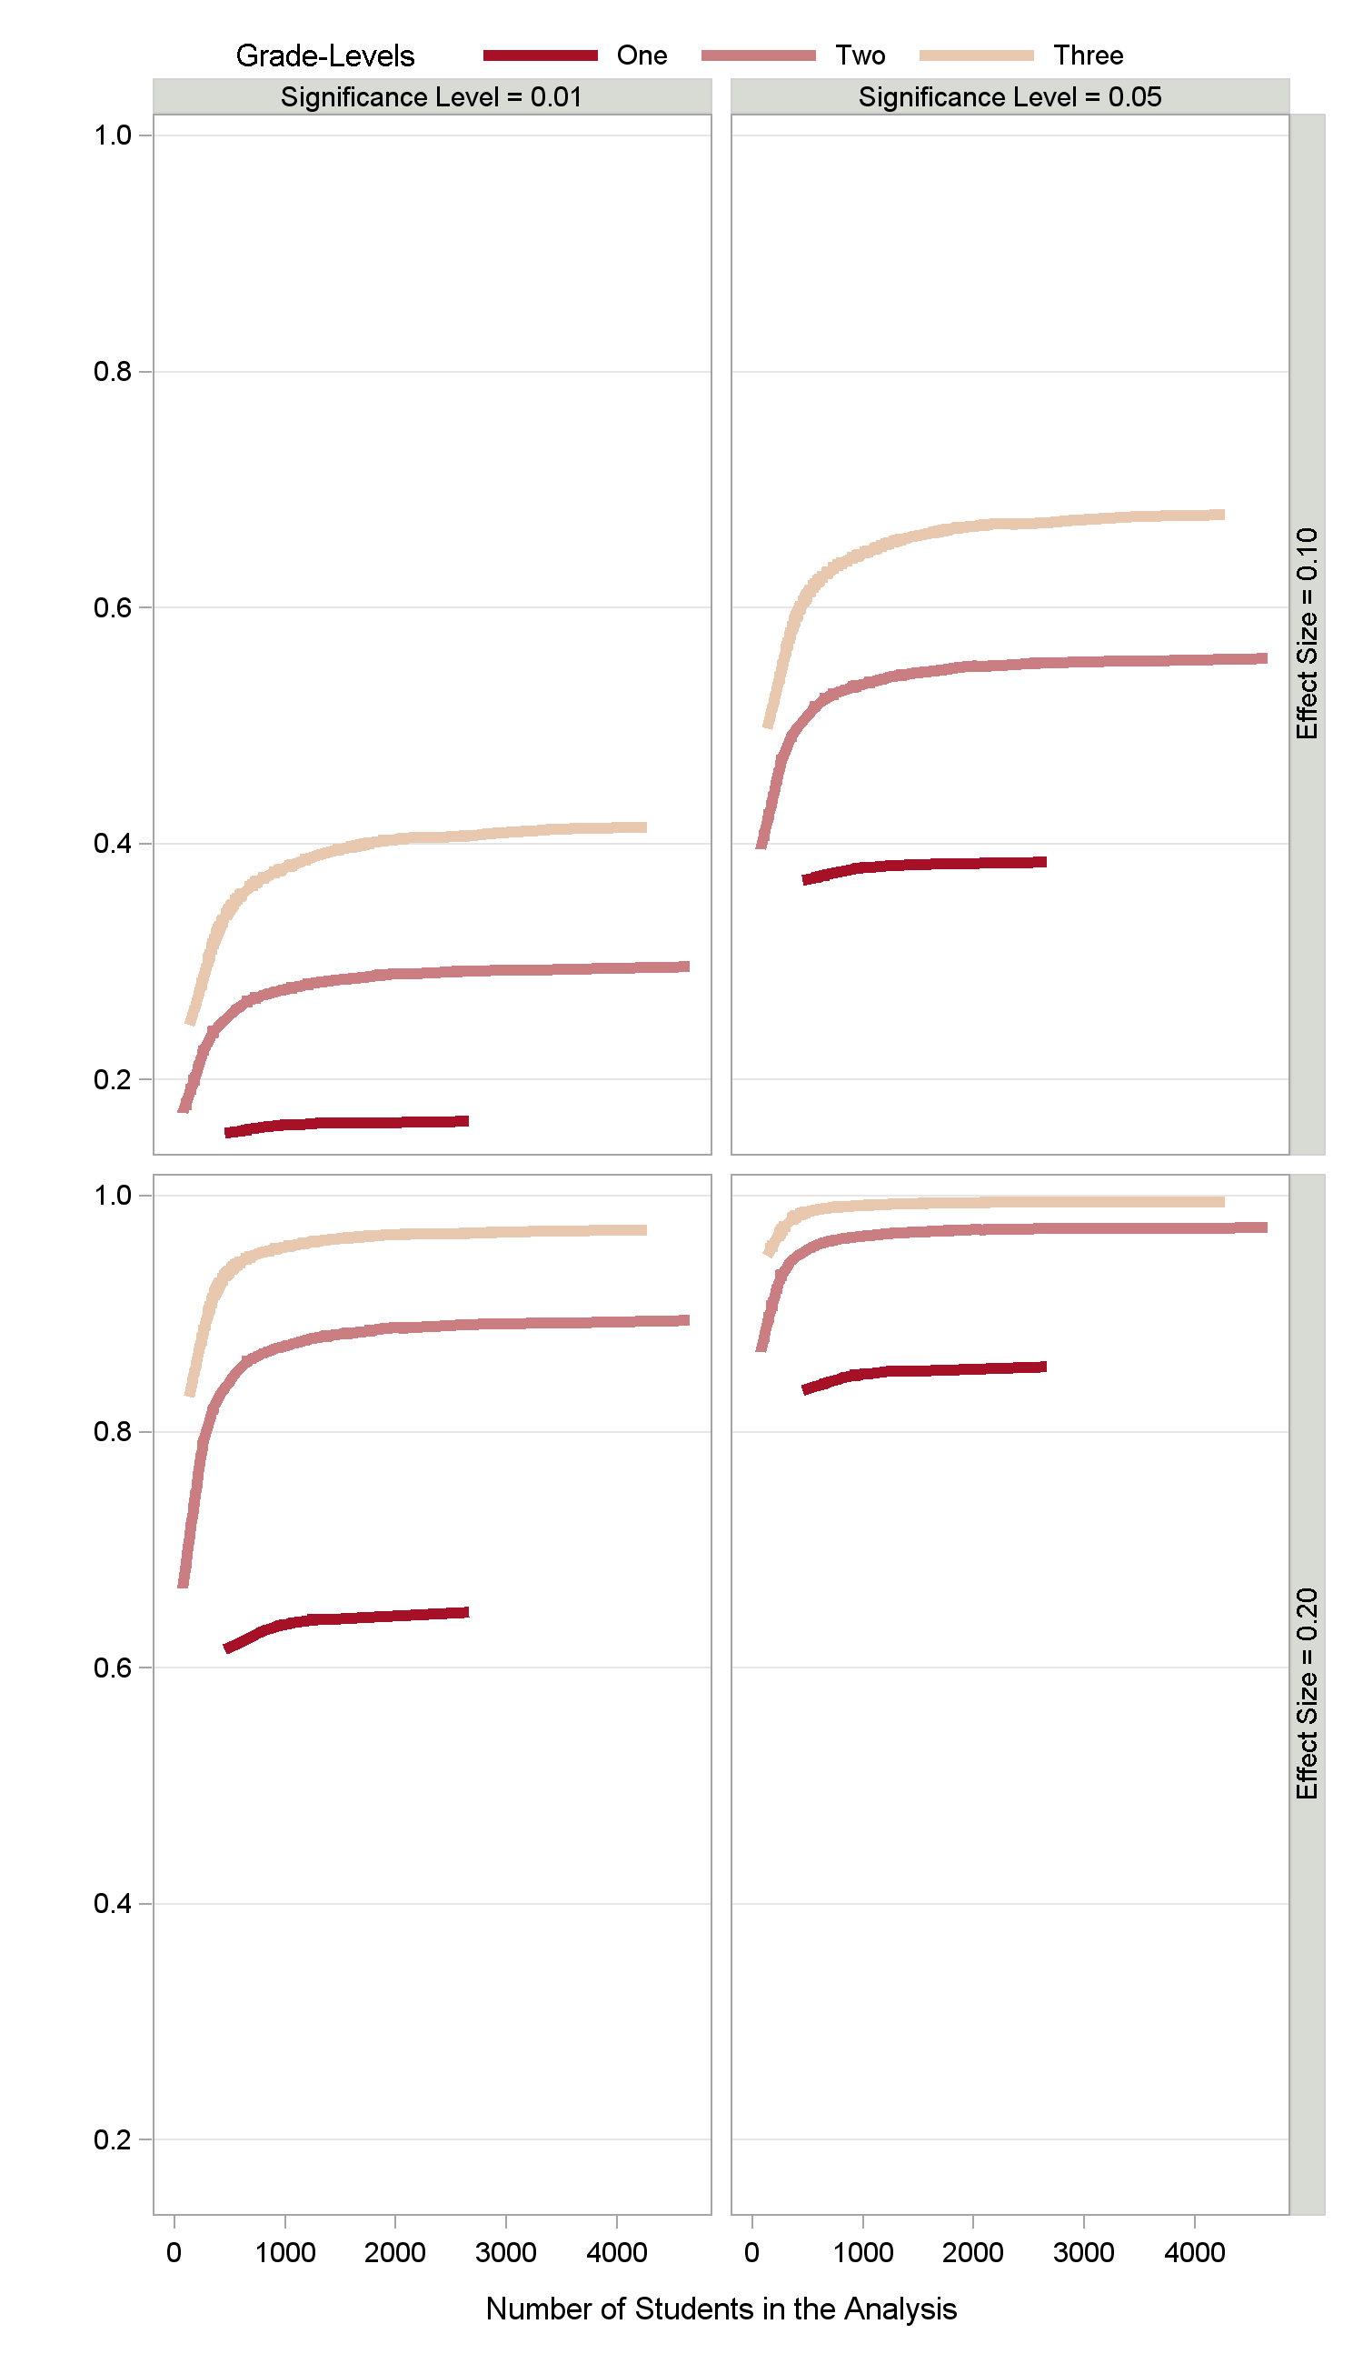

**More students or grade-levels and higher significance levels lead to higher power to detect a true effect size.**

**Power**

**Number of Students in the Analysis**