

Appalachian Information Technology Extension Services (AITES)

This research is supported by NSF-GSE/EXT 0832913

AITES, 200 Wallace Hall, Virginia Tech, Blacksburg, VA 24061| 540/231-9428| www.aites5.org

The Appalachian Information Technology Extension Service (AITES) project’s overarching goal is to increase girls’ interest in jobs requiring Information Technology (IT) skills through the development of community capacity. Emphasis is placed on developing community capacity through the training of Community Cohort Teams (CCT) which are made up of teachers, school counselors, and Extension agents as ‘primary stokers.’ These team members are tasked to train key ‘Secondary Stokers,’ such as school faculty, counselors, and parents who surround the girls. Through the transfer of knowledge between CCT members and Secondary Stokers and subsequently from these Secondary Stokers to the broader community, or ‘Tertiary Stokers’ (which may include girls/students) community capacity is being built.

**Concept of the Stoker:**

The understanding of the importance of support persons, such as school counselors, teachers, and parents, is consistent with the AITES tandem bike metaphor of the girl on the front of the bike steering and her supporter, the stoker, on the back providing encouragement and momentum.

Stokers are important adults in female students’ day-to-day lives who influence the imagined possibilities, lives, jobs or careers these students’ see for themselves. Stokers are individuals that these students may or may not directly seek advice from but are nevertheless influential to students’ self-image and school/life decisions. Examples of stokers include, but are not limited to, parents, teachers, counselors, and local community members who are role models. By increasing the stokers’ support and knowledge regarding females in IT-related jobs and careers, we increase the community capacity to support female students interest in IT-related jobs and jobs requiring IT skills.

**Spring/Summer  
 2011**



# Using Social Network Analysis to

# Inform Community Capacity Building

1

**Overall**

* 311 Secondary Stokers were reached through CCT activities conducted in VA, KY, and TN.
* The greatest outreach was to teachers.
* The lowest outreach was to parents.
* Successful knowledge transfer by CCTs is evidenced by statistically significant improvements in Secondary Stokers’ awareness of local IT opportunities and general IT knowledge; acknowledgement of gender barriers for women in IT; and more positive perceptions of IT and IT jobs.

Secondary Stokers

**Table 1: How did Secondary Stokers share AITES information**

2

**Table 2: With whom did Secondary Stokers share AITES information**

**The Purpose of using Social Network Analysis:**

Theories and tools from Social Network Analysis (SNA) serve to visualize the many vehicles and routes taken in building this community capacity. SNA provides an additional lens to make sense of project diffusion, as well as identify best practices and appropriate and effective course corrections.

3

SNA examines relationships between actors and/or actors and events via sociograms. The AITES Project Team uses PAJEK, a special software program, to create sociograms from tracking data, triangulated with all other evaluation data, to visualize knowledge transfer and diffusion of the AITES message. This document provides some sample visual representations of diffusion thus far.

AITES Sociograms are triangulated with the following existing survey data:

1. The Trainer-the-Trainer Workshop pre-tests and post-tests
2. The Retrospective post-test for Secondary Stokers
3. The Collaboration Assessment Tool (CAT)
4. The Secondary Stoker Survey

The AITES Sociograms presented in this document include:

1. Outreach to Secondary Stokers (VA, KY)
2. Tertiary Stokers (KY)

## Methods

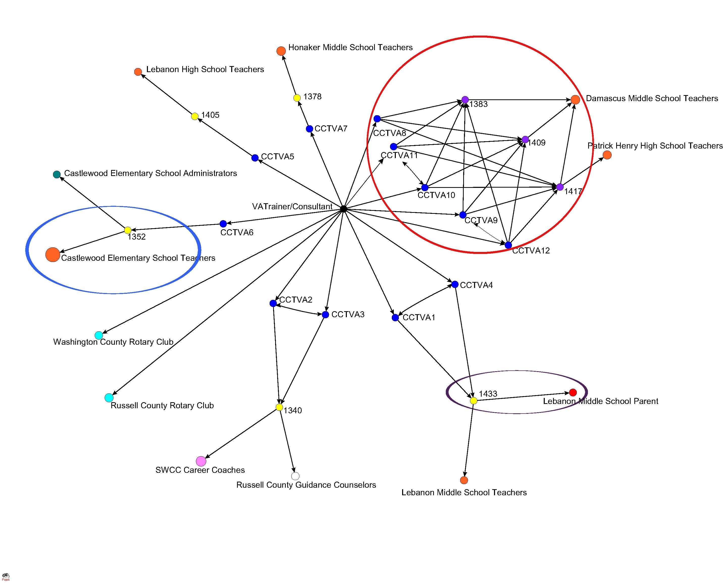

## Figure 1: VA Outreach to Secondary Stokers

**Interpretation of VA Sample Visuals**

**Circles in the VA sociogram:**

**Red Circle:** Collaboration: Collaboration allows for the sharing of resources (one example is to purchase incentives to encourage participation and retention within multiple session activities) - VA CCT members **CCTVA8-12** represent collaboration.

Trainer/Consultants may be key to reaching implementation potential in first two years of project.

**Purple Circle:** Course Corrections: Need to focus more on providing activities to parents.

**Blue Circle:** Identifying Champions: One CCT member, **CCTVA6,** is recognized as a key playerin the network for her ability to provide intensive outreach (three consecutive sessions) to over 50 community participants.

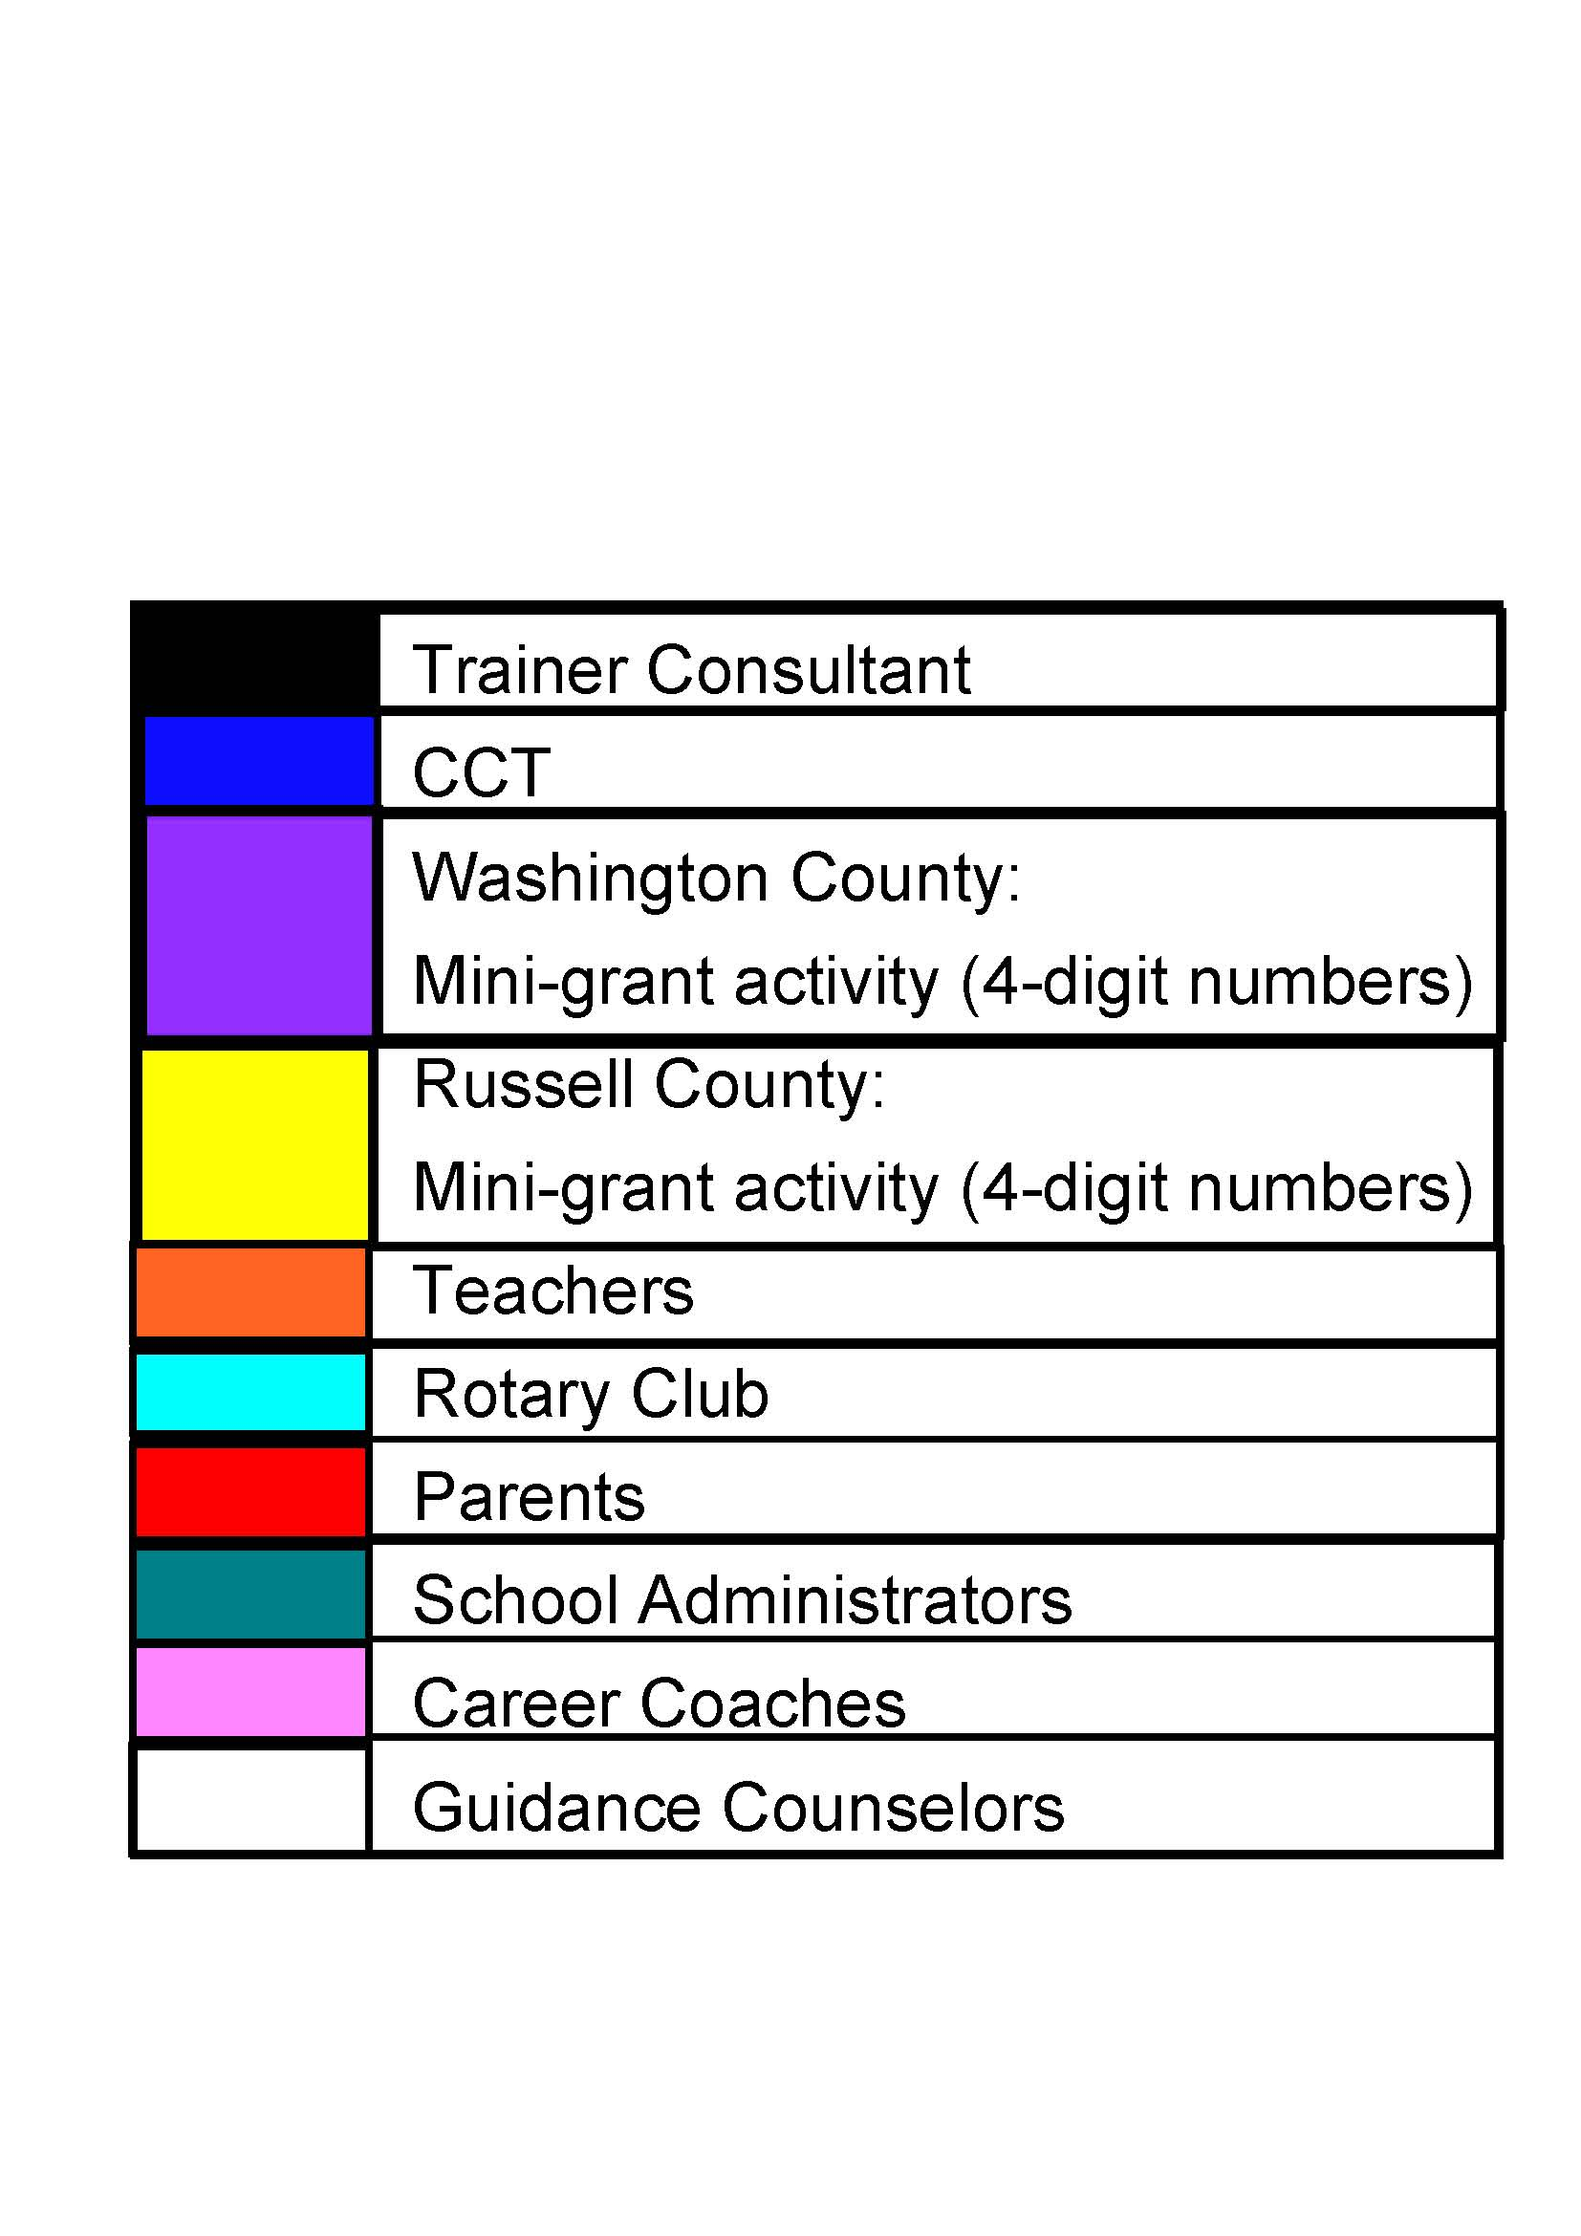

4

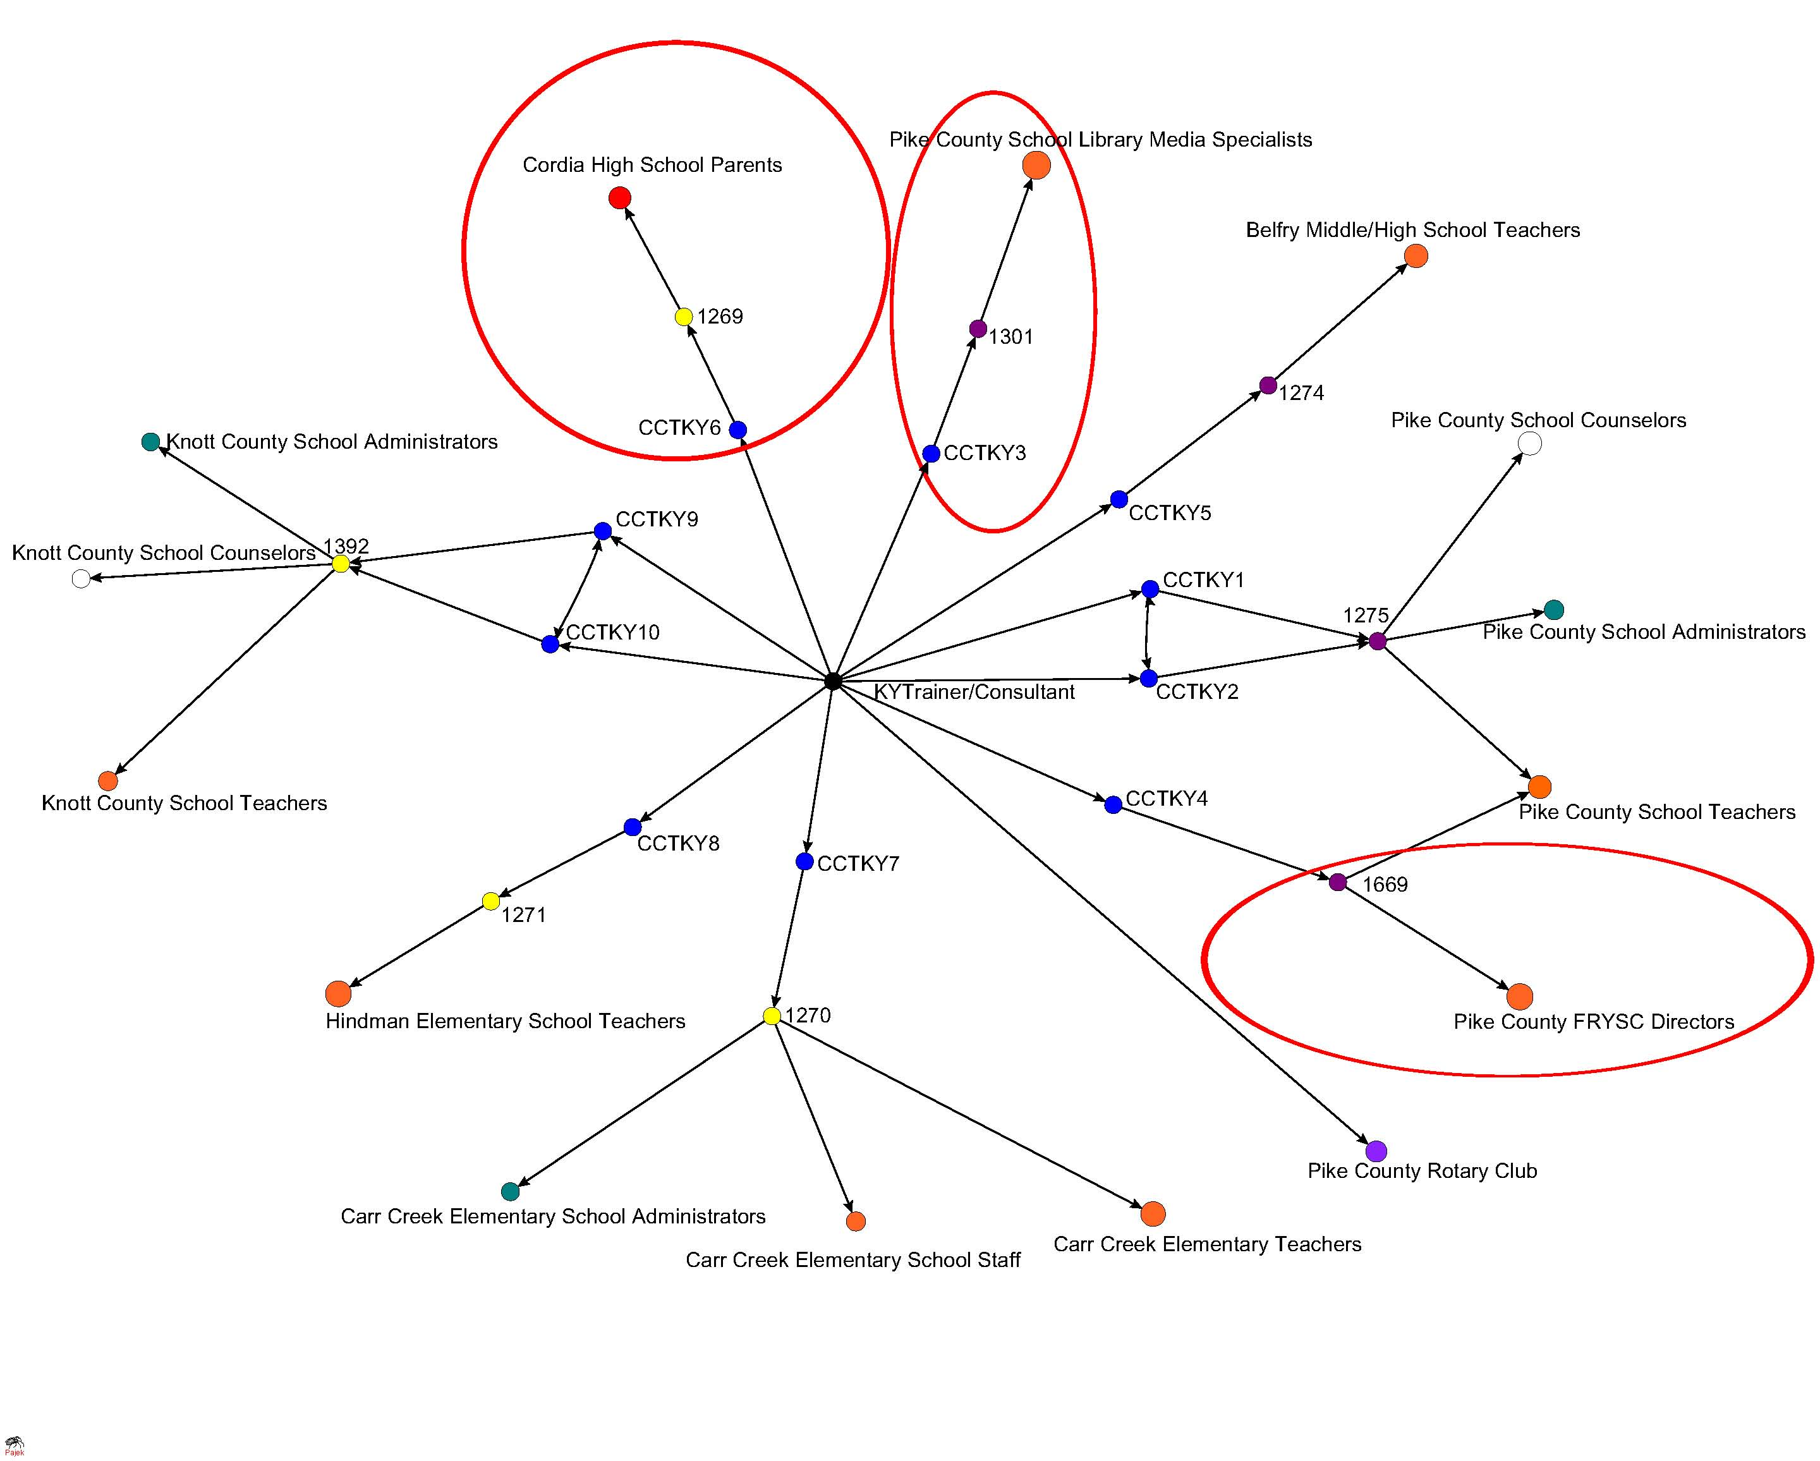

## Figure 2: KY Outreach to Secondary Stokers

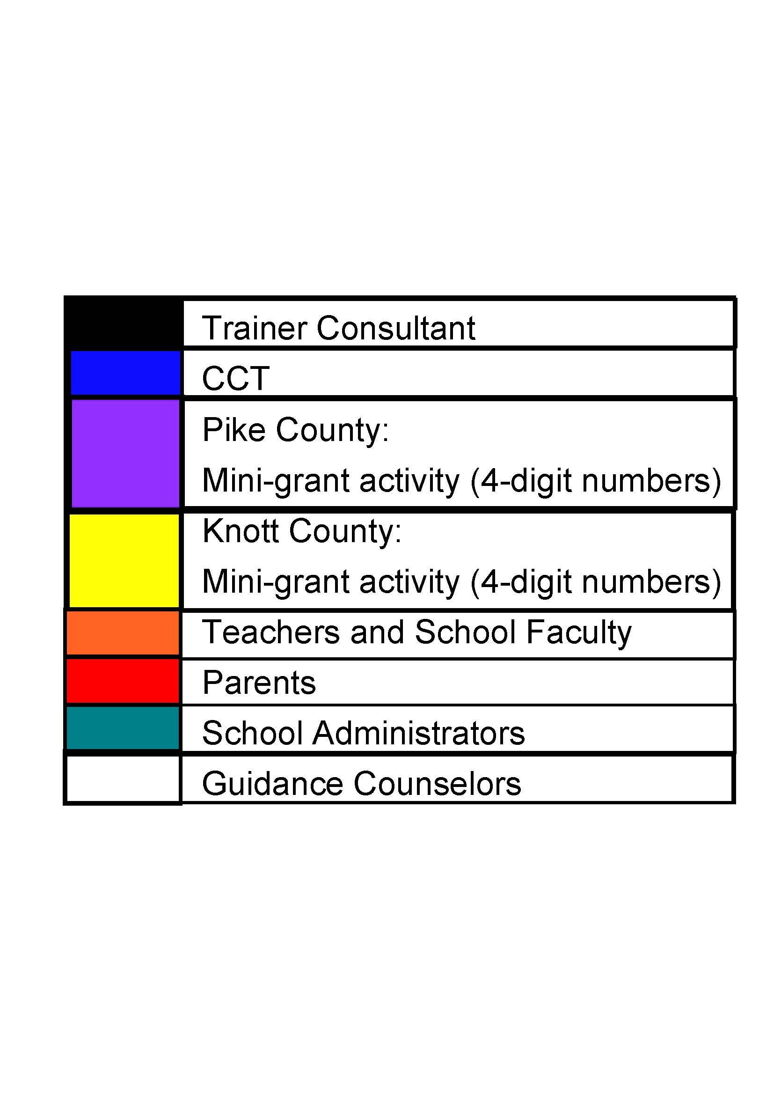

**Interpretation of KY Sample Visuals**

**Red circles in the KY sociogram:**

**Red Circles:**

Diversifying target audiences: **CCTKY3** and **CCTKY4** identify new stokers School Library Media Specialists (SMLS) and Family Resource and Youth Services (FRYSC) Directors.

Course Corrections: **CCTKY6** Need to focus more on providing activities to parents.

5

## Next Steps

•Continue to explore community capacity building longitudinally via outreach to tertiary stokers.

•Identify best practices for reaching tertiary stokers.

•Identify and provide feedback on information on course corrections when appropriate and effective.

•Explore consistency of AITES message and materials.

**Table 3: Stoker Magnification**

**Overall**

* 311 Secondary Stokers reached 1825 Tertiary Stokers in the states of VA, KY, and TN.
* This represents a 487% increase or magnification in reach from initial investment in Secondary Stokers (311) to transfer to Tertiary Stokers (1,825).
* The greatest tertiary outreach was to girls (54%), then parents (23%), school faculty and staff (17%), school administration (4%), and “other stokers” (2%).
* KY demonstrated the most success in reported tertiary outreach thus far with a 1088% magnification of reach (1,545) from Secondary Stokers (130).

Tertiary Stokers

|  |  |  |
| --- | --- | --- |
| State | Secondary Stoker | Tertiary Stoker |
| Virginia | 135 | 238 |
| Kentucky | 130 | 1545 |
| Tennessee | 46 | 45 |
| Total | 311 | 1825 |

6

Tertiary Stokers Sociogram

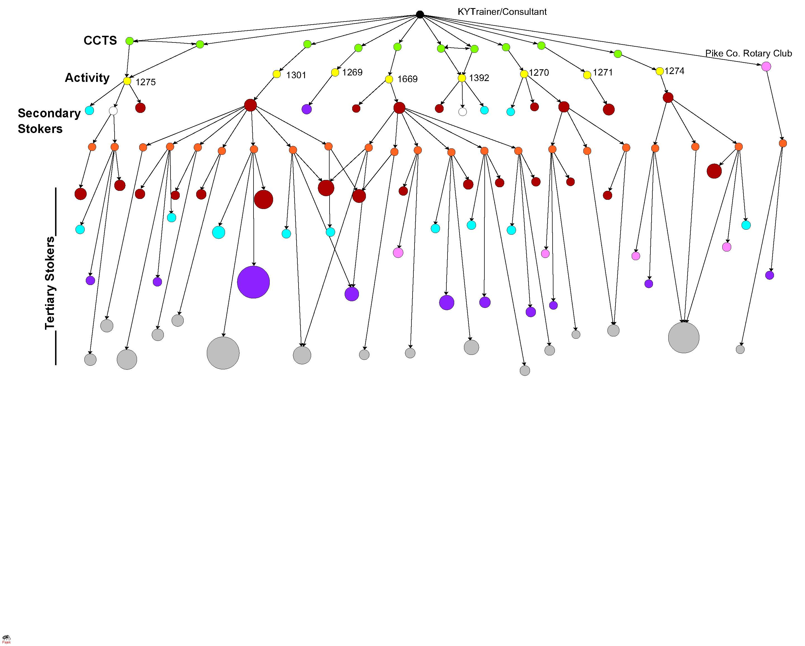

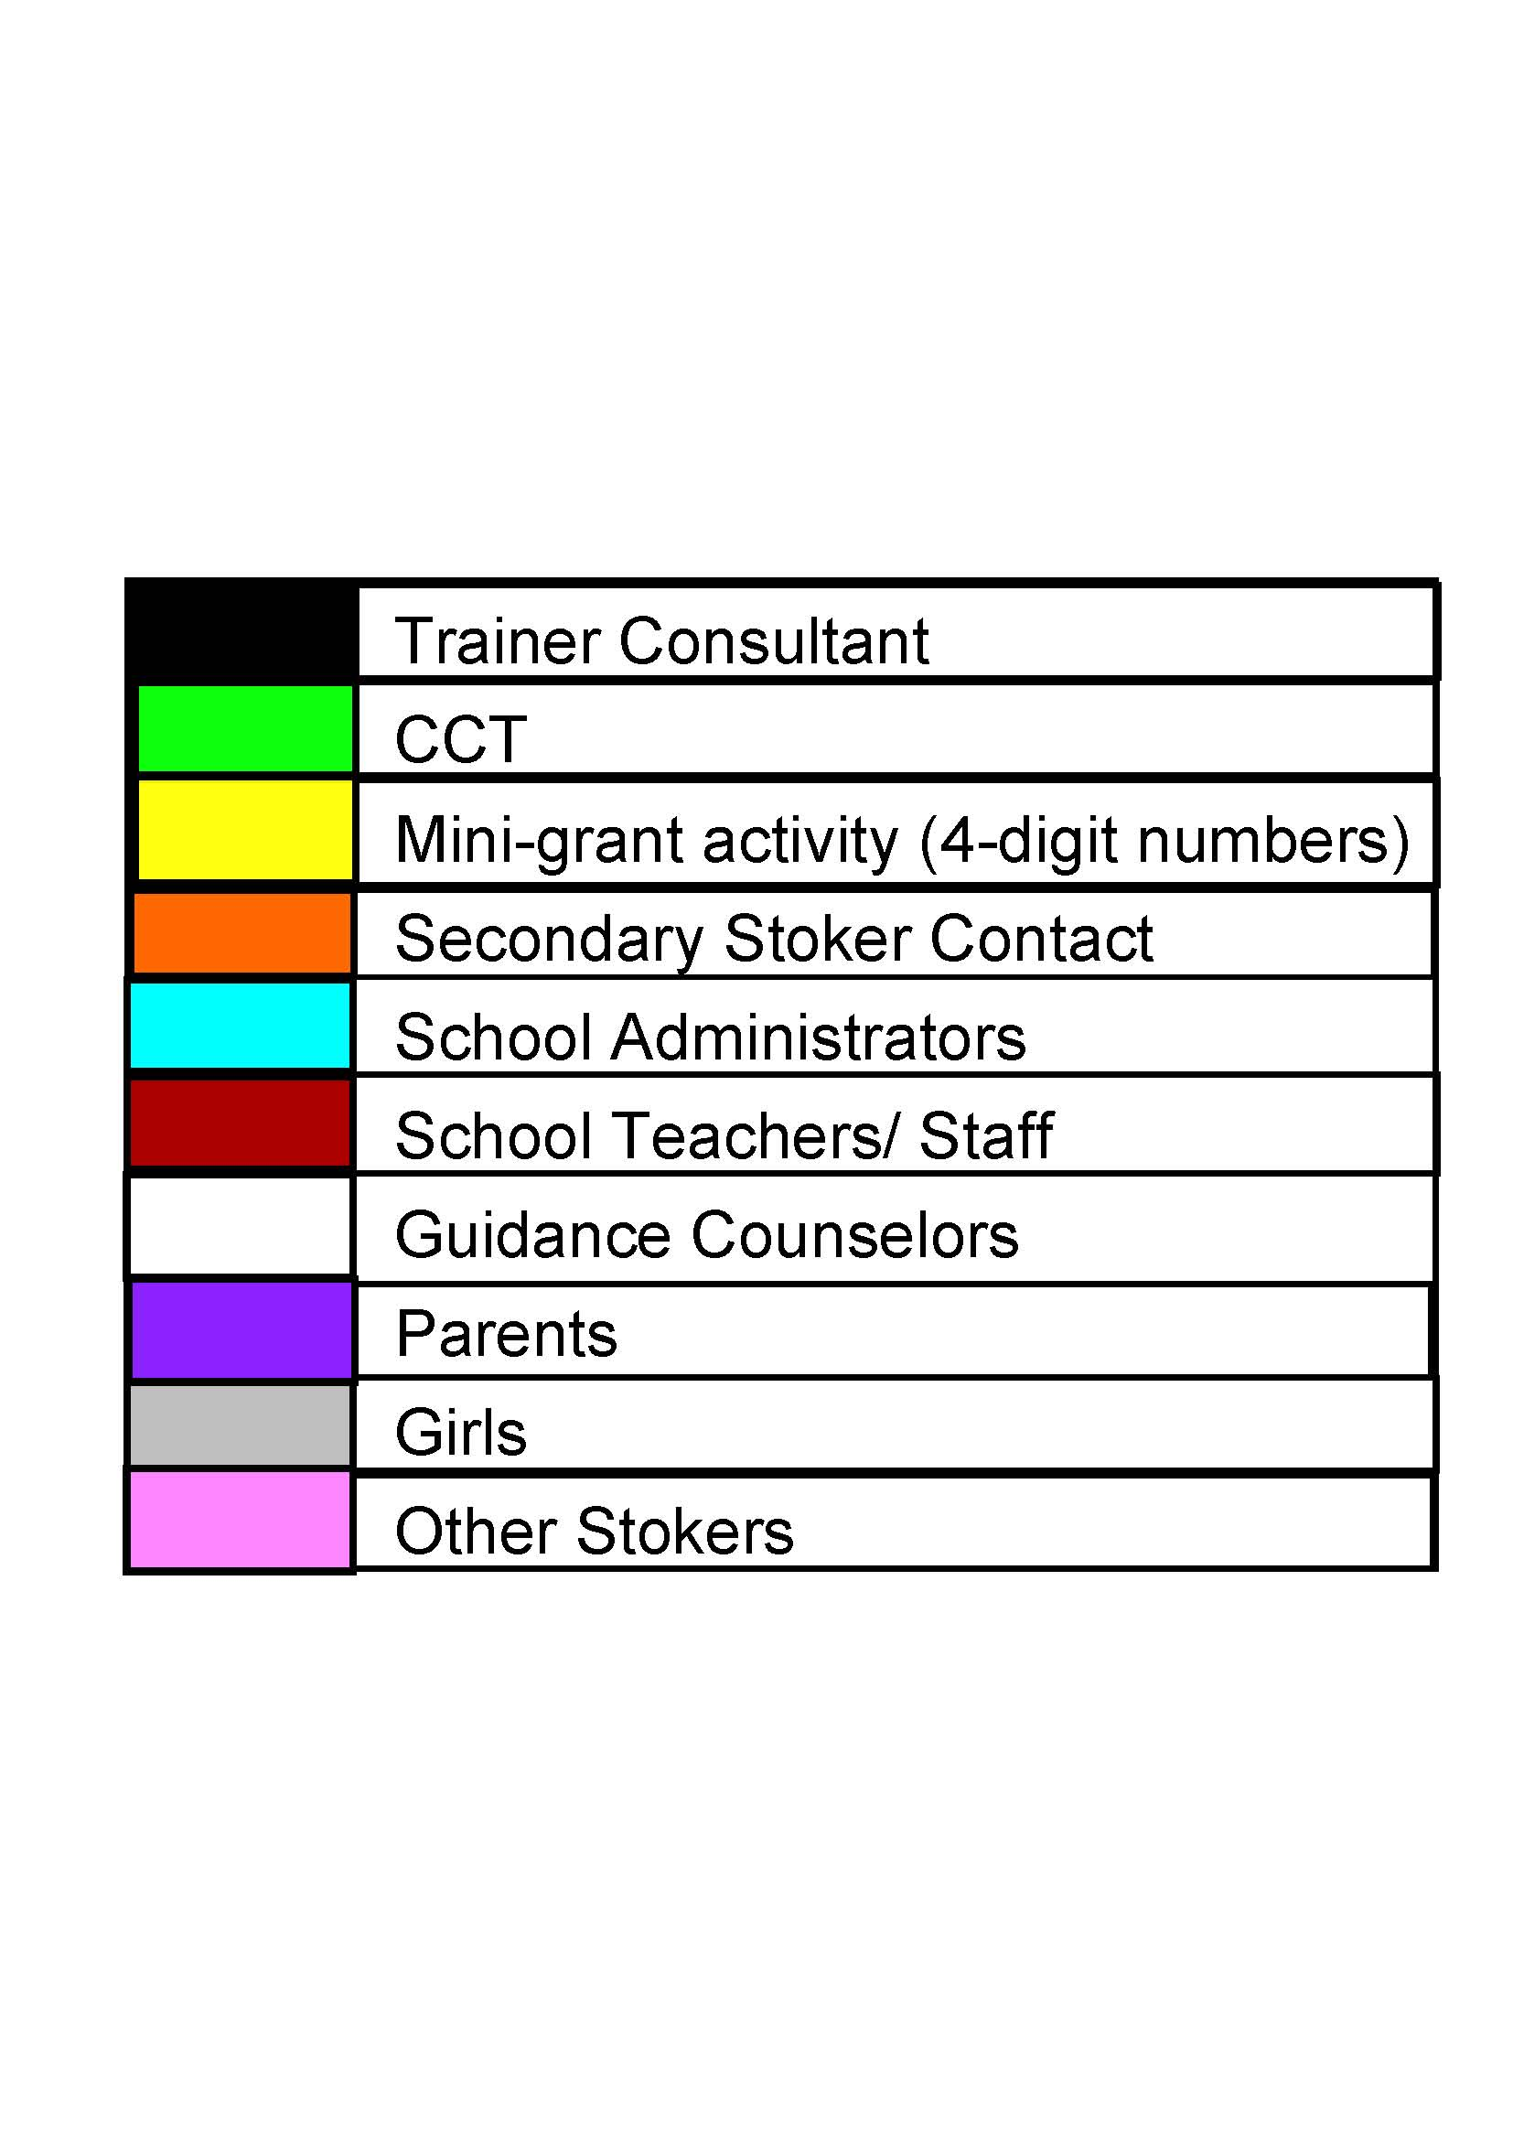

**Interpretation of Tertiary Sample Visual**

Identifying Champions:

* The activities that resulted in the greatest outreach to   
   tertiary stokers were **1274, 1669**, and **1301**.

Best Practices:

* Target key players (High school teachers, Family Resource and Youth Services Directors, and School Library Media Specialists) who have good outreach potential, a shared interest in the goals of AITES, and time to devote to the AITES message.
* Use of diverse transfer mechanisms, including informal conversations, talking in classrooms and parent groups, speaking to co-workers and their family members, distributing AITES materials, and conducting their own activities in their community.
* The use of Power of Partners and the What Can Educators Do? The use of a survey that requires participants to create action plans and makes expectations to continue the work of AITES explicit.
* Continued contact and collaboration between CCT members and interested Secondary Stokers to conduct their own activities.

7