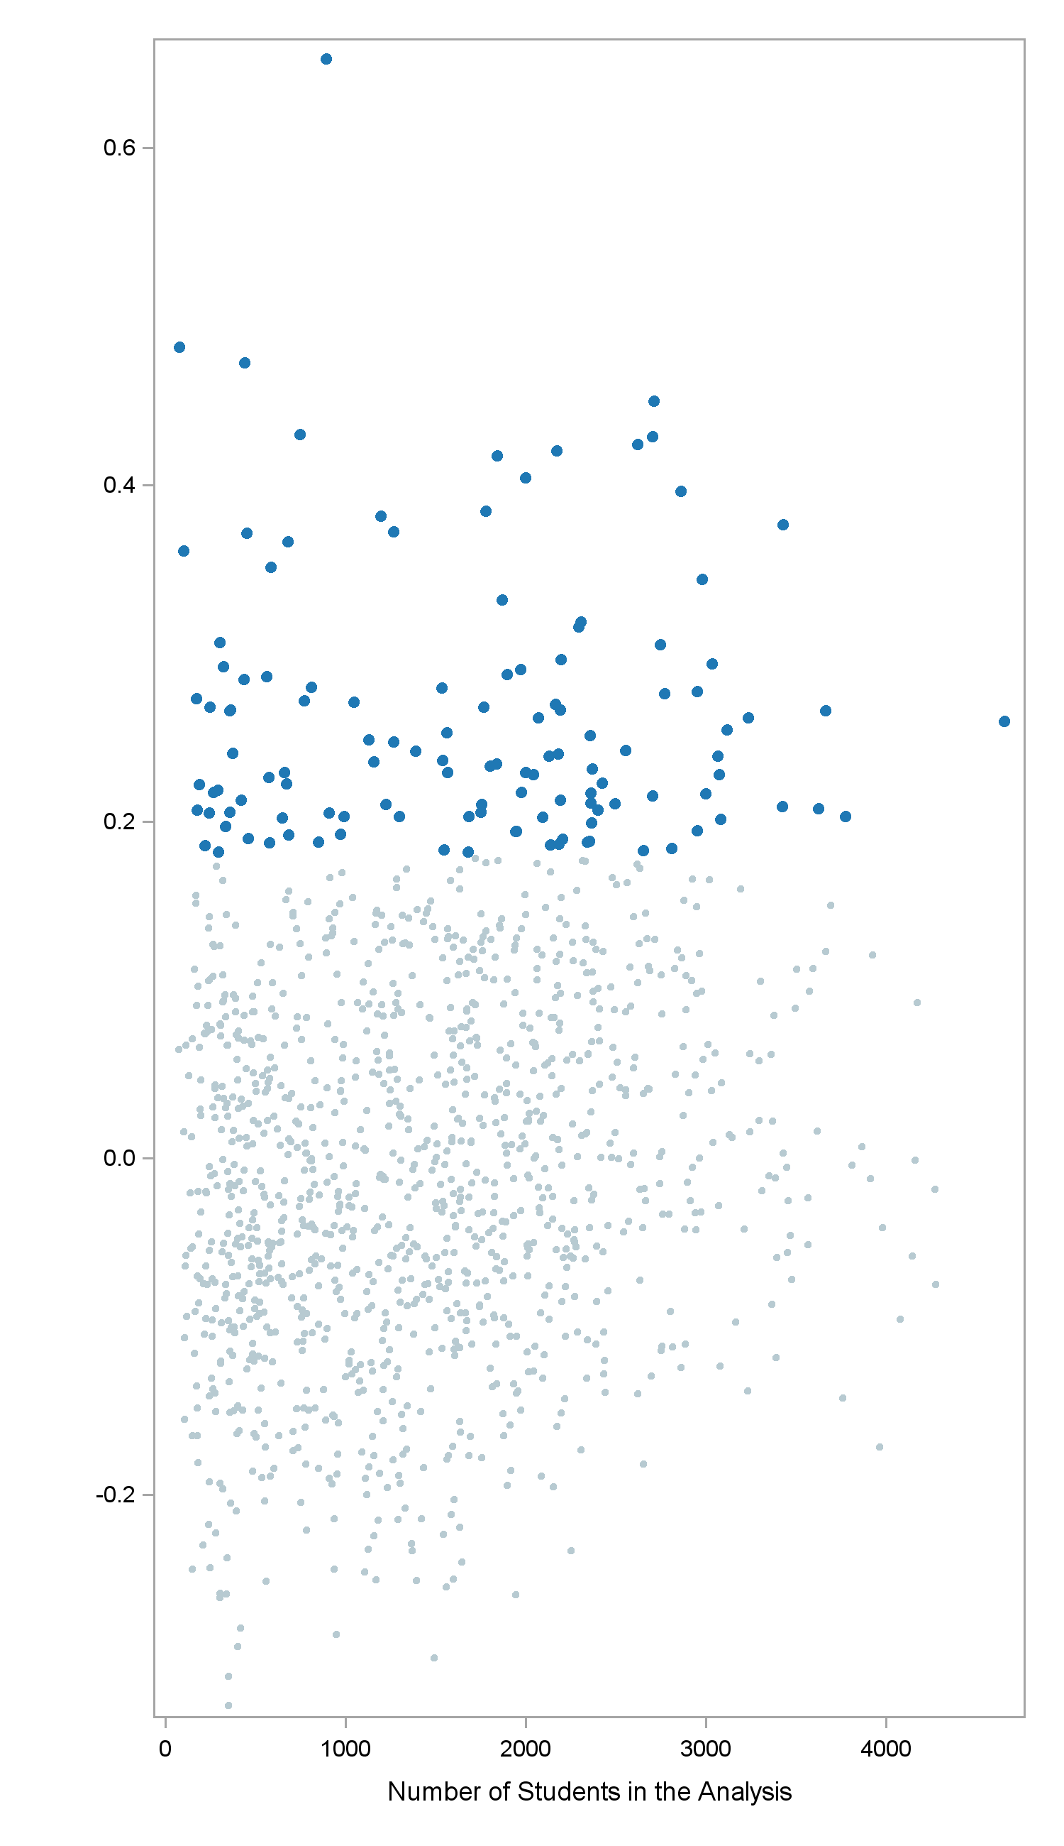

**Top 10% of school effect sizes**

**Effect**

**Size**

**Number of Students in the Analysis**

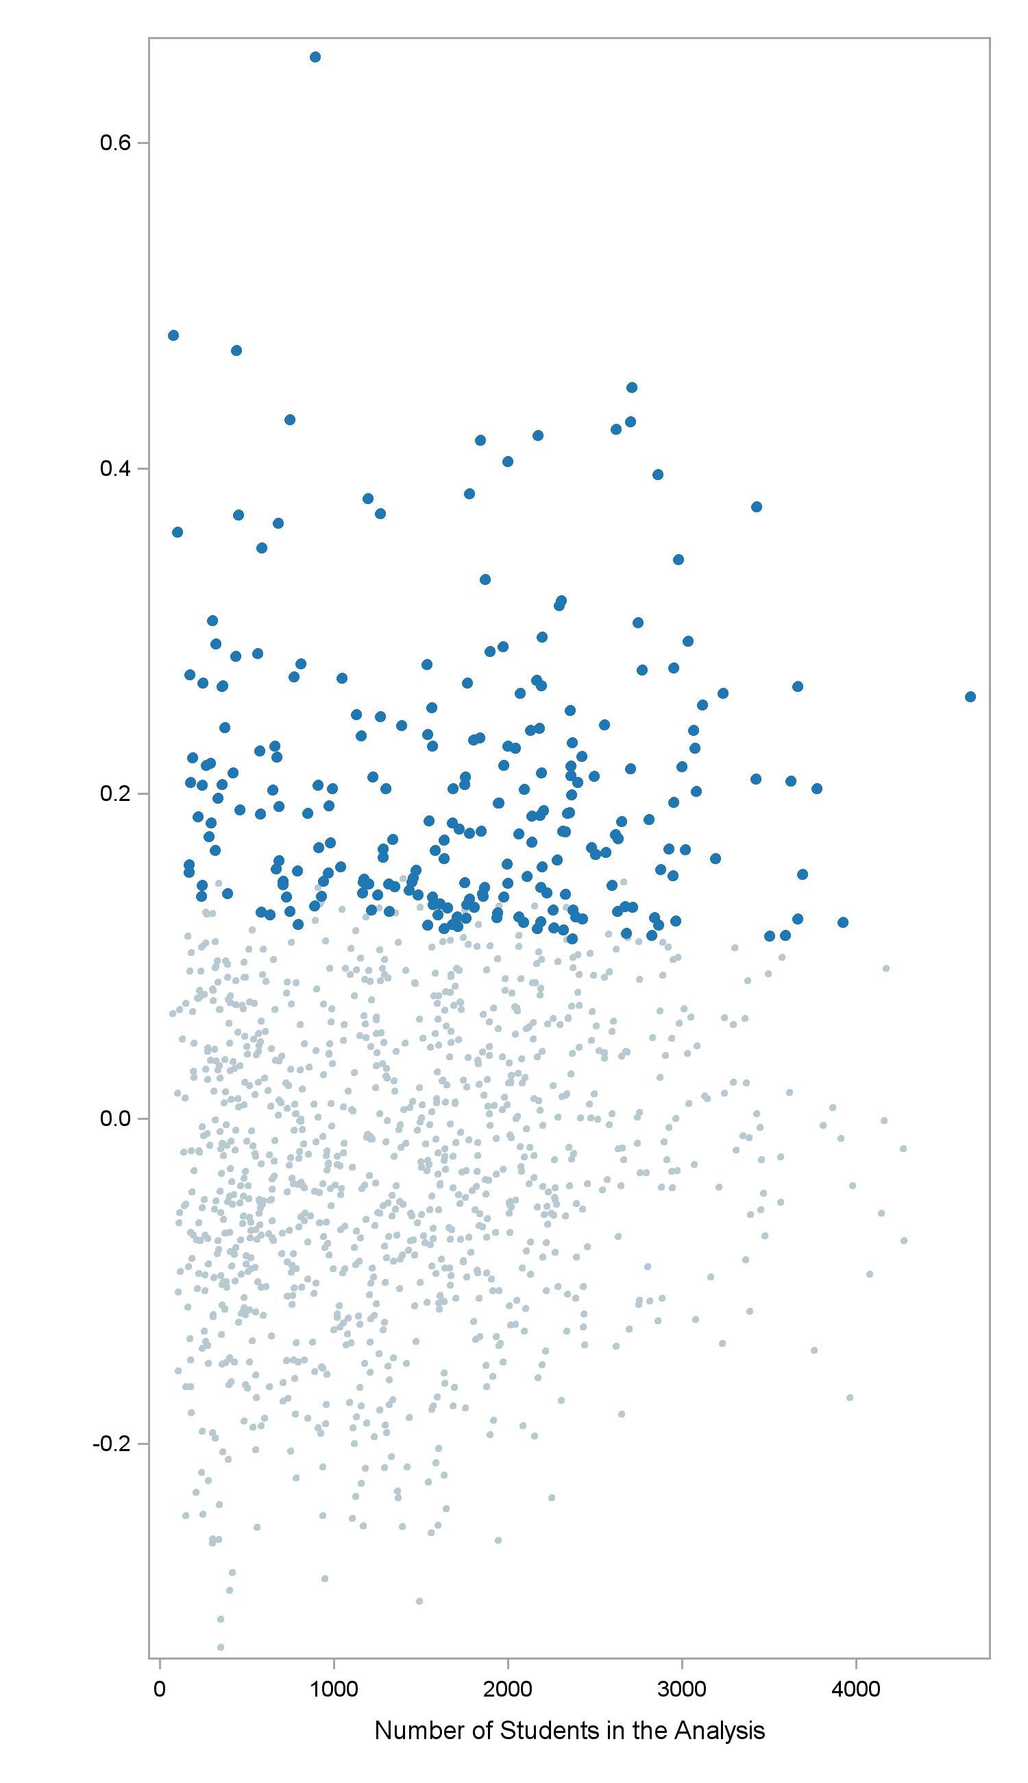

**School effect size differs statistically significantly from zero at 0.01 level**

**Effect**

**Size**

**Number of Students in the Analysis**

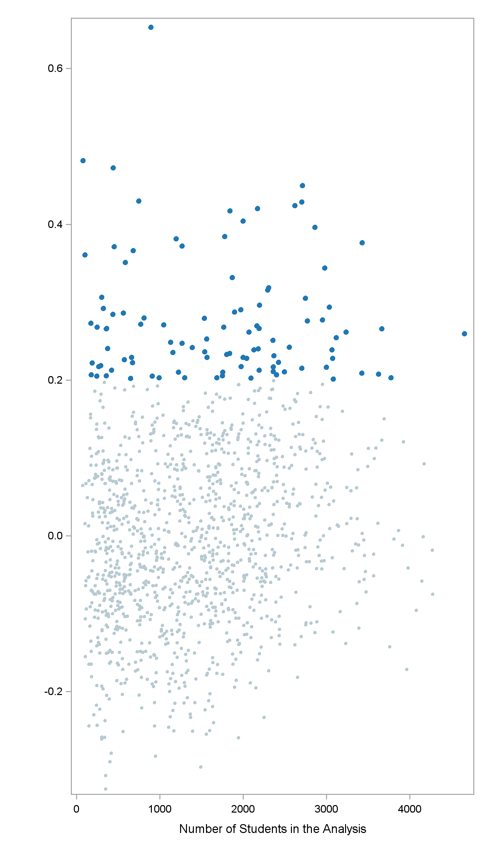

**School effect size exceeds 0.2**

**Effect**

**Size**

**Number of Students in the Analysis**

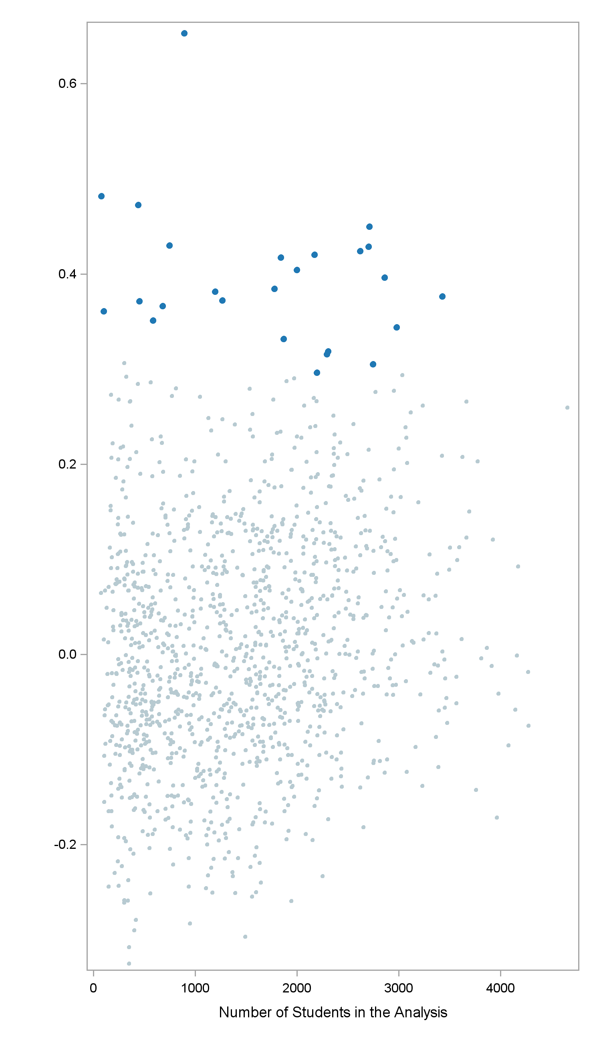

**Lower end of confidence interval exceeds school effect size of 0.2**

**Effect**

**Size**

**Number of Students in the Analysis**