***Professional Development PBS Pedagogy Pre-Institute***

**ABSTRACT**

Social network analysis (SNA) can be a powerful tool for the analysis of partnerships. Developing carefully crafted surveys that include not only frequency of interaction but also quality of interaction can be analyzed using SNA to provide rich graphic representations (sociograms) that allow evaluators and stakeholders to easily identify program trends, strengths and weaknesses. A unique use of SNA proposed by the authors allows the evaluator to compare actual sociograms with intended sociograms thereby highlighting process weaknesses and strengths. Viewing a well-designed sociogram can provide a clear picture of relationships although understanding how to depict the sociogram can be elusive. Evaluators must be practiced in thoughtful manipulation of the graphic representations. The way in which sociograms are designed is an important aspect of the analysis. This session will illustrate the difference between examples of comparisons between actual and intended networks.









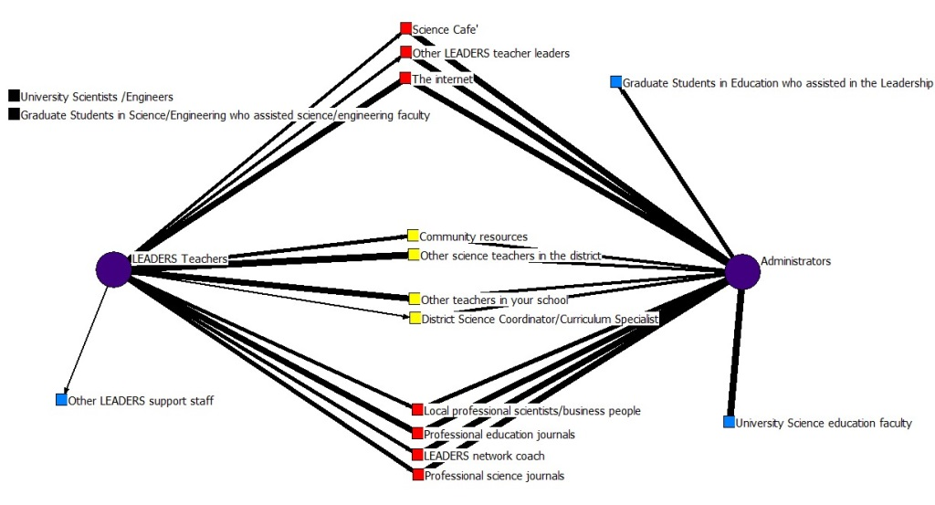

Above is the status of the Teachers LEADERS (TLs) before the Institute to the expectations of the Administrators (ADs). You will notice two resources in black nodes showing the TLs did not use, nor did the ADs expect them to. The two resources in blue off the ADs nodes show expectations that were not being met at all before the Institute. Interestingly, Other LEADERS Support Staff is being used by the TLs before the institute which was not even intended to be used after the program by the ADs. Since teachers from previous groups in LEADERS had returned to their respective schools and spread the word about the program, which is part of the LEADERS objectives, this is most likely the cause of this link.

***Professional Development PBS Pedagogy Post-Institute***

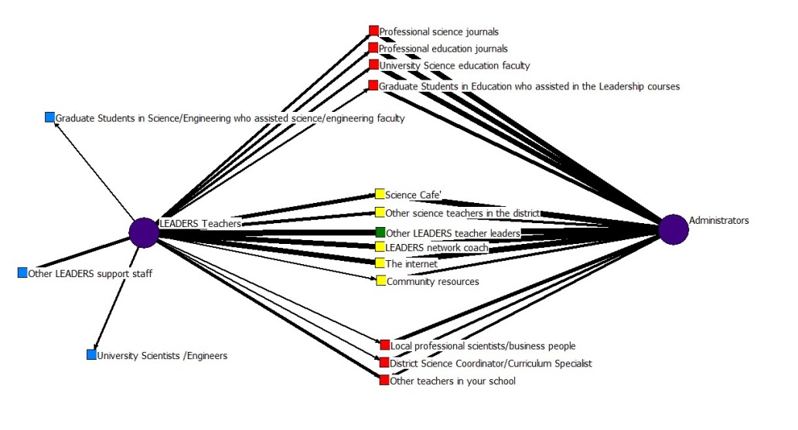

After the Institute you will quickly notice that the TLs as a group are using all resources that were expressed in the ADs expectations. The node Other LEADERS Teachers even has complete agreement on its importance of utilization. You will notice the black nodes are now gone because the TLs began using them as a resource, beyond the expectations of the ADs. While the number of nodes in the center indicating higher consensus have increased there are still many nodes in red expressing the TLs are not using those resources to the ADs expectations. Gower’s Multidimensional Layout helps us visualize these differences the farther from the center green node, the greater the difference between the TLs actual usage of the resource and the ADs expectations. Chi-test illustrates how the TLs reported scores have moved towards the ADs expected overall.



***Guide to understanding sociograms***

**Lines or Links**- The thickness of the line represent the level of frequency of importance of usage to the resource in the network

**Purple Nodes**- Actors: Administrators or LEADERS Teachers

**Green Nodes**- Resources that have complete agreement, they selected those resources at the same frequency. E.2-3.0.2-3.0nterval.y of usage.S Teachersx: 3.0-3.0

**Yellow Nodes**- Resources that both actors selected but did not agree on the frequency within one interval. Ex: 2.2-3.0

**Red Nodes**- Resources chosen by both actors and they did not agree on the frequency of usage beyond one interval.1.2-3.0

**Blue Nodes**- Resource only selected by one actor.

**Black Nodes**- Resources not chosen by either actor.