

**Maximizing the Impact of STEM Outreach (MISO)**

**Teacher Technology Survey**

|  |
| --- |
|  |

**Background**The Maximizing the Impact of STEM Outreach (MISO) project at NCSU is an I3 NSF funded project. The purpose of MISO is to creatively integrate longitudinal evaluation with innovation within NC State’s K-12 STEM outreach programs. The MISO teacher survey was created to help MISO project partners collect and analyze data with regards to teacher confidence and efficacy toward STEM teaching beliefs.

All MISO surveys are administered by MISO project staff and may be accessed via a free online surveying system. After the survey has been completed by program participants during each survey window, a report (along with the raw data) is provided to the project coordinator upon request.

**Appropriate Uses**The MISO Teacher Survey is intended to measure the changes in STEM teaching confidence and efficacy among teachers engaged in various NCSU outreach programs. It provides information to help MISO project partners to make decisions about possible changes to their program. Specifically, project partners may use the MISO Teacher Survey data to complete evaluation and research activities. In addition to specific project data, the survey data are aggregated across all MISO project partners in an effort to show the effect of NCSU STEM outreach projects across campus.

**Data and Reporting**MISO collects *perceptive data* (what respondents think or feel) about their STEM teaching confidence and efficacy level. Responses are analyzed through the online system and each report provides a picture of participants’ beliefs as a whole, presented as frequencies and percentages of responses to all items, and as bar chart representations of those values.

**Interpreting the Data**

Interpretation can be made at the individual item level but is more powerful at the construct (factor) level. Survey data presented in this report is simply listed in the order in which the survey items were given to respondents. The instruments from which the survey was developed were based on two subscales- Personal Teaching Efficacy and Teaching Outcome. Statistical analyses at the conclusion of the pilot period will determine the final factor structure. Future reports will present the data via their respective constructs.

The MISO Teacher Response Scale:

|  |  |  |  |  |  |
| --- | --- | --- | --- | --- | --- |
| **Strongly Disagree** | **Somewhat Disagree** | **Neither Agree nor Disagree** | **Somewhat Agree** | **Strongly Agree** | **I do not Know** |

**Examples**

In the first profile, most respondents either “Strongly Agree” or “Agree” with the statement in the survey item. Since this item is worded positively, it is reasonable to infer that most respondents feel they can impact student technology performance.

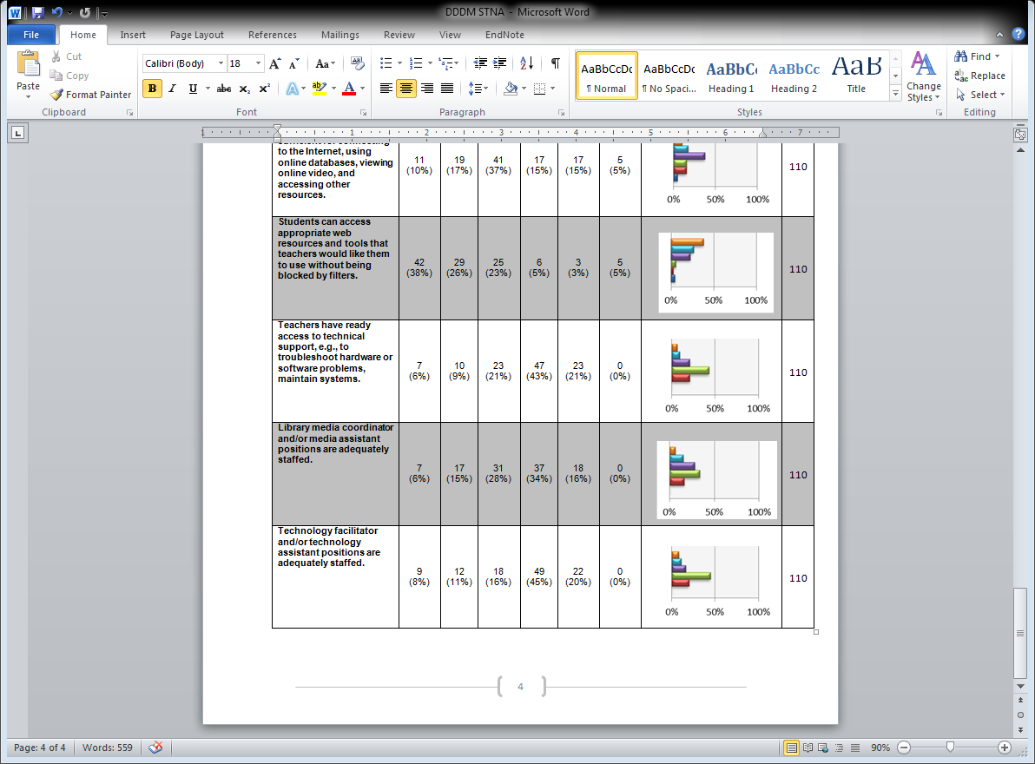

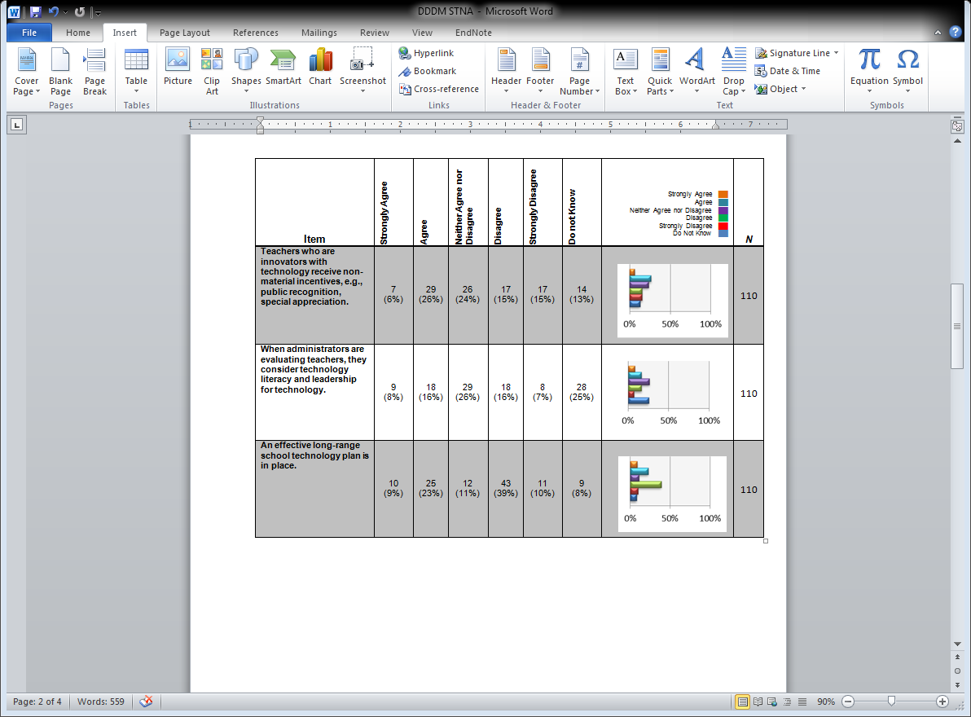In the second profile, a large number of respondents report that they “Do Not Know” about parental feelings which indicates that they do not have enough information to respond to the statement. This suggests that a large portion of the teachers are not fully informed about this area, or that they do not have access to some of the information necessary to respond. In this case, gathering additional information about why the respondents are uninformed might prove helpful.

In the third profile, more teachers “Agree” with the statement, than “Disagree” with it. This profile suggests that substantial disagreement exists within teachers in the program, making this an area of concern for decision makers. Few chose “Do Not Know,” suggesting that awareness in this area is good. Again, this indicates a need to gather additional data.



This fourth and final profile represents teachers who are very mixed in their thinking about the area examined. Additional information will be required to determine why people feel the way that they do about issues relating to this item. It is difficult to make any specific inferences, but it is obvious that this is an area of concern**.**

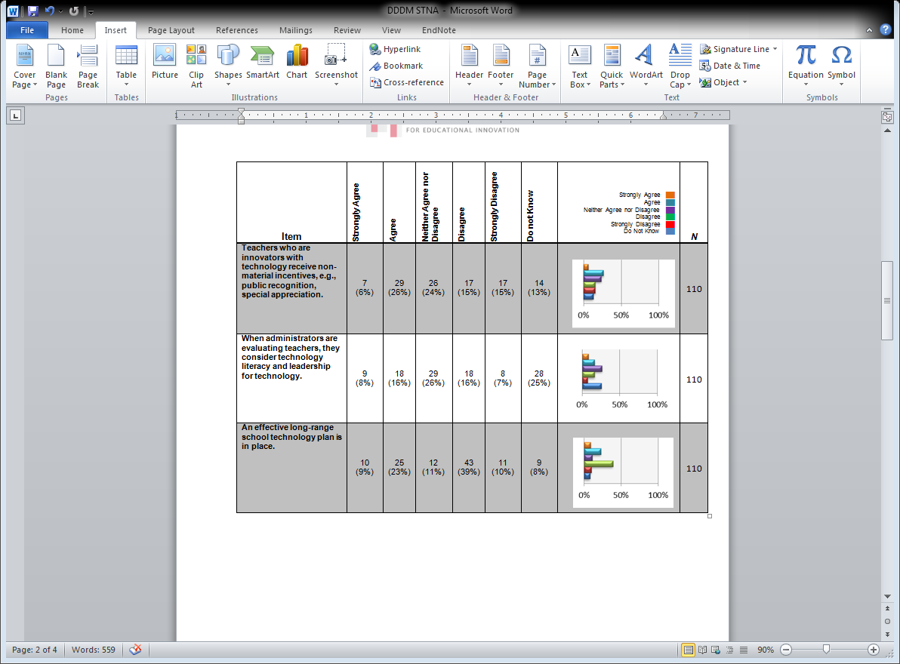

**The remaining pages contain an actual MISO report.**

**MISO Pilot Technology Teacher Survey**

|  |  |  |  |  |  |  |  |  |
| --- | --- | --- | --- | --- | --- | --- | --- | --- |
| **Item** | **Strongly Disagree** | **Somewhat Disagree** | **Neither Agree nor Disagree** | **Somewhat Agree** | **Strongly Agree** | **I don't not Know** | **Strongly Disagree ██  Somewhat Agree ██  Neither Agree nor Disagree ██ Somewhat Agree ██  Strongly Agree ██  Do Not Know ██** | ***N*** |
| When a student does better than usual in technology, it is often because the teacher exerted a little extra effort. | 0 (0%) | 5 (16%) | 1 (3%) | 16 (50%) | 9 (28%) | 1 (3%) |  | 32 |
| I am continually finding better ways to teach technology. | 0 (0%) | 1 (3%) | 0 (0%) | 4 (13%) | 26 (81%) | 1 (3%) |  | 32 |
| When the technology grades of students improve, it is most often due to their teacher having found a more effective teaching approach. | 0 (0%) | 3 (9%) | 2 (6%) | 16 (50%) | 10 (31%) | 1 (3%) |  | 32 |
| I know the steps necessary to teach technology concepts effectively. | 0 (0%) | 1 (3%) | 2 (6%) | 15 (47%) | 14 (44%) | 0 (0%) |  | 32 |
| I am not confident that I can monitor technology activities well. | 9 (28%) | 12 (38%) | 3 (9%) | 6 (19%) | 2 (6%) | 0 (0%) |  | 32 |
| If students are underachieving in technology, it is most likely due to ineffective technology teaching. | 1 (3%) | 6 (19%) | 10 (31%) | 11 (34%) | 3 (9%) | 1 (3%) |  | 32 |
| I am not confident that I can teach technology effectively. | 14 (45%) | 10 (32%) | 2 (6%) | 3 (10%) | 2 (6%) | 0 (0%) |  | 31 |
| The inadequacy of a student's technology background can be overcome by good teaching. | 0 (0%) | 1 (3%) | 3 (10%) | 15 (48%) | 12 (39%) | 0 (0%) |  | 31 |
| The low technology achievement of students cannot generally be blamed on their teachers. | 2 (6%) | 11 (34%) | 7 (22%) | 10 (31%) | 1 (3%) | 1 (3%) |  | 32 |
| When a low achieving child progresses in technology, it is usually due to extra attention given by the teacher. | 0 (0%) | 4 (13%) | 2 (6%) | 16 (50%) | 1 (3%) | 0 (0%) |  | 32 |
| I understand technology concepts well enough to be effective in teaching technology. | 0 (0%) | 2 (6%) | 1 (3%) | 16 (50%) | 13 (41%) | 0 (0%) |  | 32 |
| Increased effort in technology teaching produces little change in students' technology achievement. | 10 (31%) | 19 (59%) | 0 (0%) | 3 (9%) | 0 (0%) | 0 (0%) |  | 32 |
| The teacher is generally responsible for the achievement of students in technology. | 1 (3%) | 5 (16%) | 4 (13%) | 11 (34%) | 11 (34%) | 0 (0%) |  | 32 |
| Students' achievement in technology is directly related to their teacher's effectiveness in technology teaching. | 0 (0%) | 5 (16%) | 4 (13%) | 11 (35%) | 10 (32%) | 1 (3%) |  | 31 |
| If parents comment that their child is showing more interest in technology at school, it is probably due to the performance of the child's teacher. | 0 (0%) | 5 (16%) | 2 (6%) | 12 (39%) | 11 (35%) | 1 (3%) |  | 31 |
| I am not confident that I can explain to students why technology works. | 12 (39%) | 13 (42%) | 3 (10%) | 2 (6%) | 1 (3%) | 0 (0%) |  | 31 |
| I am confident that I can answer students' technology questions. | 1 (3%) | 1 (3%) | 4 (13%) | 15 (48%) | 10 (32%) | 0 (0%) |  | 31 |
| I wonder if I have the necessary skills to teach technology. | 7 (23%) | 9 (30%) | 4 (13%) | 8 (27%) | 0 (0%) | 2 (7%) |  | 30 |
| Effective technology teaching has little influence on the achievement of students with low motivation. | 14 (48%) | 8 (28%) | 1 (3%) | 5 (17%) | 1 (3%) | 0 (0%) |  | 29 |
| Given a choice, I would not invite the principal to evaluate my technology teaching. | 16 (52%) | 9 (29%) | 1 (3%) | 3 (10%) | 2 (6%) | 0 (0%) |  | 31 |
| When a student has difficulty understanding a technology concept, I am not confident that I know to how to help the student understand it better. | 10 (31%) | 13 (41%) | 3 (9%) | 5 (16%) | 1 (3%) | 0 (0%) |  | 32 |
| When teaching technology, I am confident enough to welcome student questions. | 0 (0%) | 3 (9%) | 0 (0%) | 11 (34%) | 17 (53%) | 1 (3%) |  | 32 |
| I don't know what to do to turn students on to technology. | 20 (65%) | 8 (26%) | 0 (0%) | 3 (10%) | 0 (0%) | 0 (0%) |  | 31 |
| Even teachers with good technology teaching abilities cannot help students learn technology. | 17 (55%) | 11 (35%) | 1 (3%) | 2 (6%) | 0 (0%) | 0 (0%) |  | 31 |